CSS ISLAMIC STUDIES · T4KB
بِسۡمِ ٱللَّهِ ٱلرَّحۡمَٰنِ ٱلرَّحِيمِ
Topic IV — Human Rights, Human Dignity, Women and the Family
The Knowledge Base · Human rights, the Farewell Sermon, the UDHR, human dignity and equality, the status and rights of women, and the family
Ten chapters built from the syllabus and from the twelve questions set on this topic between 2015 and 2026, with the contemporary debates, the examiner's record, five likely questions, a numbered one-liner bank and chapter-by-chapter revision notes. Every point carries its evidence — the Quran first, then the Hadith, then the Companions and the scholars — inside the point itself.
Edition of September 2026 · covers the papers of 2015–2026 · written for CSS 2027 and after
Contents
HOW TO BUILD THE CONTENTS
The Contents below is left empty on purpose. In Microsoft Word, right-click anywhere on the grey line below and choose Update Field → Update entire table → OK. The full table of contents with page numbers will appear.
On a Mac: right-click (or Control-click) the line → Update Field. If you edit the notes later, repeat this step to refresh the page numbers. You can also press Ctrl + A then F9 (Windows) to update every field in the document at once.

How to Use This Document 8
What this topic covers 8
How this document is built 9
Part Zero — The ABC Before the Chapters 10
0.1 The words of this topic 10
0.2 Two kinds of rights, one accountability 10
Chapter 1 · Human Rights in Islam: Concept, Sources and Features 12
1.1 The concept of human rights 12
(1) The general meaning 12
(2) The Islamic concept 12
1.2 The sources of human rights in Islam 12
1.3 The Maqasid al-Shari'ah — the map of rights 13
1.4 The main human rights in Islam 13
(1) The right to life 13
(2) The right to dignity and honour 14
(3) The right to equality 14
(4) The right to justice 15
(5) Freedom of religion 15
(6) The right to property 15
(7) The right to privacy 16
(8) The right to freedom of opinion and to criticise rulers 16
(9) The right to basic needs 16
(10) Personal responsibility — no collective punishment 17
(11) The right to a fair trial 17
1.5 The features of human rights in Islam 17
Chapter 2 · The Farewell Sermon: The Charter of Human Rights 19
2.1 The occasion 19
2.2 The main declarations — each a human right 20
(1) Sanctity of life, property and honour 20
(2) Equality of all human beings 20
(3) The rights of women 21
(4) Abolition of riba — economic justice 21
(5) Abolition of blood feuds 21
(6) Personal responsibility 21
(7) Rights of inheritance 21
(8) Rights of servants and the weak 22
(9) Brotherhood and the rule of the Book 22
(10) Accountability and conveying the message 22
2.3 Why it is 'the basic document for the awakening of the conscience of mankind' 22
Chapter 3 · Islam and the UDHR: A Comparative and Critical Analysis 24
3.1 The UDHR — the facts 24
3.2 The Muslim documents 24
3.3 Where Islam and the UDHR agree 24
3.4 Where they differ — the comparative analysis 25
(1) The source of rights 25
(2) Rights and duties 25
(3) The enforcement mechanism 25
(4) The scope 25
(5) Individual and society 25
(6) The limits of freedom 25
(7) The points of tension 25
3.5 The critical analysis 26
(1) Criticism of the UDHR and its practice 26
(2) Honest self-criticism of the Muslim world 26
(3) The verdict 26
Chapter 4 · Human Dignity and Equality: Men and Women, Colour, Race and Creed 27
4.1 The sources of human dignity in the Quran 27
(1) Honoured by Allah 27
(2) Created in the best form 27
(3) The spirit of Allah breathed into him 27
(4) The vicegerent on earth 28
(5) Knowledge given to him 28
(6) The angels bowed to him 28
(7) The universe made subservient 28
(8) The trust (amanah) 29
4.2 Equality irrespective of colour, race and creed 29
(1) One origin 29
(2) Diversity for recognition, not rank 30
(3) Allah looks at hearts, not faces 30
(4) The Sunnah in practice 30
(5) Equality of creed — dignity of non-Muslims 31
(6) Equality before the law 31
4.3 Dignity of men and women 32
4.4 Dignity protected in every condition 32
4.5 Social justice in an Islamic society (the 2023 note) 33
(1) Meaning 33
(2) The pillars of social justice in Islam 33
(3) Pakistan 34
Chapter 5 · The Status of Women: Before Islam and in Islam 35
5.1 Women before Islam — the world of the 7th century 35
5.2 The revolution Islam brought 36
(1) The same soul — equal in humanity 36
(2) No blame of woman for the Fall 36
(3) Equal spiritual reward 36
(4) Equal in the Hereafter, equal in accountability 36
5.3 Better rights than other systems — the comparison (2021) 37
Chapter 6 · Women as Daughter, Wife, Mother and Citizen 38
6.1 As a daughter 38
(1) The right to life 38
(2) Good news, not grief 39
(3) Paradise for raising daughters 39
(4) Equal love and justice among children 39
(5) Education and upbringing 39
(6) Consent in marriage 40
(7) Inheritance 40
(8) The model father 40
6.2 How the rights of daughters are denied by Muslims today (the 2023 limb) 40
Pakistani law against these practices 41
6.3 As a wife 41
(1) Marriage by her consent, with mahr 41
(2) Maintenance 41
(3) Kind treatment 42
(4) Mutual rights 42
(5) 'Qawwamun' — responsibility, not superiority 43
(6) Right to leave an unhappy marriage 43
(7) Her own property, name and identity 43
6.4 As a mother 44
6.5 As a citizen and member of society 44
Chapter 7 · The Economic Rights of Women: Mahr, Nafaqah and Inheritance 46
7.1 The principle — a woman's wealth is her own 46
7.2 Mahr — the bridal gift 46
7.3 Nafaqah — maintenance 46
7.4 Inheritance — the right of women 47
(1) The Quranic declaration 47
(2) The shares of women 47
(3) Why a son receives twice a daughter — the wisdom 48
(4) Cases where the woman receives equal or more 48
(5) No one may cut her out 49
(6) The Hanafi order of distribution 49
7.5 The denial of women's inheritance in Pakistan 49
Chapter 8 · Women's Rights and the Feminist Movement 51
8.1 Feminism — meaning and waves 51
8.2 Where Islam agrees with the demands of women's movements 51
8.3 Where Islam differs 51
(1) Equality is not identity 51
(2) Freedom within moral limits 52
(3) The family, not the individual, as the unit 52
(4) Revelation, not changing opinion, as the standard 52
8.4 The balanced Islamic answer — 'equity, not identity' 52
Chapter 9 · The Rights of Non-Muslims, Children, the Elderly, Workers and the Disabled 54
9.1 Rights of non-Muslims (minorities) in an Islamic state 54
(1) The Quranic principles 54
(2) The Prophetic guarantee 55
(3) Their rights 55
(4) The practice 55
(5) Pakistan 55
9.2 Rights of children 55
9.3 Rights of the elderly and parents 57
9.4 Rights of workers 57
9.5 Rights of persons with disabilities 58
Chapter 10 · The Institution of the Family and Its Challenges 59
10.1 The family in Islam — purpose and foundation 59
10.2 The structure of the Islamic family 60
10.3 The functions of the family — why society's stability depends on it (2015) 61
10.4 Safeguards Islam built around the family 61
10.5 The challenges to the family in the present era (2026) 61
(1) Social and cultural 61
(2) Technological 62
(3) Economic 62
(4) Ideological 62
(5) Violence and injustice within families 62
10.6 The Islamic solutions 62
Part Two — Contemporary Challenges, Narratives and Hot Debates 63
11.1 The UDHR and the Cairo Declaration — two languages of rights 63
11.2 Women's-rights campaigns in Pakistan — the balanced answer 63
11.3 Cultural practices against Islam 63
11.4 Family breakdown 63
11.5 The elderly, children and persons with disabilities 63
Part Three — The Examiner's Record and Five Likely Questions 65
12.1 Every question on this topic, 2015–2026 65
12.2 What the record teaches 65
12.3 Five likely questions 65
Part Four — The One-Liner Bank 67
One-liners · Human rights in Islam 67
One-liners · The Farewell Sermon 67
One-liners · Islam and the UDHR 67
One-liners · Dignity and equality 68
One-liners · Status of women 68
One-liners · Daughter, wife, mother, citizen 68
One-liners · Economic rights and inheritance 69
One-liners · Other rights and the family 69
Part Five — Revision Notes · Topic 4 71
R4.0 The topic in ten lines 71
R4.1 Chapter 1 · Human rights in Islam 71
R4.2 Chapter 2 · The Farewell Sermon 71
R4.3 Chapter 3 · Islam and the UDHR 72
R4.4 Chapter 4 · Dignity, equality, social justice 72
R4.5 Chapter 5 · Status of women: before and in Islam 72
R4.6 Chapter 6 · Daughter, wife, mother, citizen 72
R4.7 Chapter 7 · Economic rights 73
R4.8 Chapter 8 · Feminism 73
R4.9 Chapter 9 · Others' rights 73
R4.10 Chapter 10 · The family 73
R4.11 Part Two · Today 74
R4.12 The figures to draw 74

How to Use This Document

What this topic covers
Topic 4 carries the syllabus lines 'Human rights and status of woman in Islam' and 'Dignity of men and women', and the questions on the family that the examiner links to them. It is the second-heaviest topic: twelve questions in nine of the twelve papers.
Syllabus line / past question | Where it is taught
Human rights in Islam — concept, sources (2022) | Chapter 1
The Farewell Sermon and human rights (2020; 2023 note) | Chapter 2
Islam and the UDHR — comparative and critical (2026) | Chapter 3
Dignity irrespective of colour, race and creed (2020); human dignity and greatness (2024); social justice (2023 note) | Chapter 4
Status of women; better rights than other religions (2021, 2022) | Chapters 5 and 6
Rights of daughters and their denial (2023) | Chapter 6
Inheritance of women (2017) | Chapter 7
Women's rights and the feminist movement (2019) | Chapter 8
Non-Muslims, children, the elderly, workers (never asked — due) | Chapter 9
The family — stability (2015) and challenges (2026) | Chapter 10

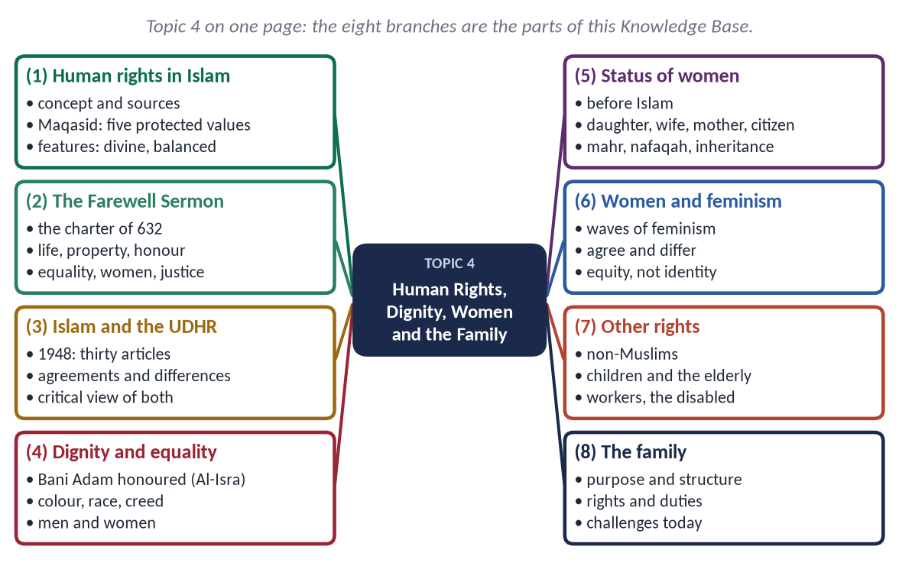
Figure 1 · Topic 4 on one page. The eight branches are the parts of this Knowledge Base.

How this document is built
1. Part Zero — the ABC: the words of the topic and the map of rights.
2. Part One — ten chapters, divided down to four levels of headings; in every point the evidence comes Quran → Hadith → practice of the Companions → scholars.
3. At-a-glance charts after long sections — the names only, for one-look revision.
4. Part Two — contemporary challenges and hot debates.
5. Part Three — the examiner's record and five likely questions.
6. Part Four — the numbered one-liner bank.
7. Part Five — chapter-by-chapter revision notes.
EXAMINER'S EYE · THIS TOPIC IN THE PAPER
Women's rights five times, each in a new frame (inheritance, feminism, comparison with other religions, human rights, daughters). Human dignity and rights five times (Farewell Sermon twice, colour and creed, dignity and greatness, the UDHR). The family twice, always 'in the present era'. The examiner rewards the honest admission of the gap between Islamic teaching and Muslim practice (2023: 'how these are denied by Muslims').

Part Zero — The ABC Before the Chapters

0.1 The words of this topic
Term | Arabic | Meaning in this topic
Huquq | حُقُوق | Rights (singular haqq — also 'truth').
Huquq Allah | حُقُوقُ الله | The rights of Allah: worship, obedience.
Huquq al-'Ibad | حُقُوقُ الْعِبَاد | The rights of people — not forgiven unless the wronged person forgives.
Karamah | كَرَامَة | Dignity, honour — given to all the children of Adam (Al-Isra 70).
Musawat | مُسَاوَاة | Equality.
'Adl | عَدْل | Justice: giving everyone his due.
Maqasid al-Shari'ah | مَقَاصِدُ الشَّرِيعَة | The objectives of the Shari'ah: protecting faith, life, intellect, lineage and property.
Khutbat Hajjat al-Wada' | خُطْبَةُ حَجَّةِ الْوَدَاع | The Farewell Sermon (10 AH).
Mahr | مَهْر | The bridal gift from husband to wife — hers alone.
Nafaqah | نَفَقَة | Maintenance: food, clothing, shelter — the husband's duty.
Mirath | مِيرَاث | Inheritance.
Khula' | خُلْع | Dissolution of marriage at the wife's request.
Qawwamun | قَوَّامُون | Protectors and maintainers — a responsibility, not a superiority (An-Nisa 34).
Dhimmi / Mu'ahad | ذِمِّي / مُعَاهَد | A non-Muslim citizen under the protection of an Islamic state.
Usrah | أُسْرَة | Family.
Silat al-Rahim | صِلَةُ الرَّحِم | Keeping ties with relatives.

0.2 Two kinds of rights, one accountability
Islam divides all rights into Huquq Allah (حُقُوقُ الله) and Huquq al-'Ibad (حُقُوقُ الْعِبَاد). Allah may forgive a failure in His own rights; He does not forgive a wrong done to a person until that person forgives. This makes human rights a matter of faith and the Hereafter, not only of law.
✦ HADITH
أَتَدْرُونَ مَا الْمُفْلِسُ؟
“Do you know who the bankrupt is?” (Muslim)
➜ The one who comes with prayer, fasting and Zakat, but had abused, slandered and struck people — his good deeds are given to those he wronged.

Chapter 1 · Human Rights in Islam: Concept, Sources and Features

1.1 The concept of human rights

(1) The general meaning
Human rights are the rights a person has because he is a human being — life, dignity, freedom, equality, justice, property and the basic needs of life.

(2) The Islamic concept
In Islam, rights are given by Allah, the Creator, not granted by a king, parliament or the UN. They therefore:
- cannot be taken away by any ruler or majority;
- come joined with duties — every right of one person is a duty of another;
- are part of worship and accountability — violating them is a sin, not only a crime.
✦ QURAN
﴿وَلَقَدۡ كَرَّمۡنَا بَنِيٓ ءَادَمَ وَحَمَلۡنَٰهُمۡ فِي ٱلۡبَرِّ وَٱلۡبَحۡرِ وَرَزَقۡنَٰهُم مِّنَ ٱلطَّيِّبَٰتِ وَفَضَّلۡنَٰهُمۡ عَلَىٰ كَثِيرٖ مِّمَّنۡ خَلَقۡنَا تَفۡضِيلٗا﴾
“And We have certainly honored the children of Adam and carried them on the land and sea and provided for them of the good things and preferred them over much of what We have created, with [definite] preference.” (Al-Isra, Quran)
➜ 'We have honoured the children of Adam' — dignity is a gift of Allah to every human being, before any law gives it.

1.2 The sources of human rights in Islam
- (a) The Quran — the principles: dignity (Al-Isra 70), equality (Al-Hujurat 13), justice (An-Nisa 135), life (Al-Ma'idah 32), no compulsion (Al-Baqarah 256).
- (b) The Sunnah — the practice: the Charter of Madinah, the Farewell Sermon, the treaties.
- (c) The practice of the Rightly-Guided Caliphs — accountability of rulers, welfare, rights of non-Muslims.
- (d) Ijma' and ijtihad — the jurists' rules on the rights of the accused, prisoners, minorities and women.

1.3 The Maqasid al-Shari'ah — the map of rights
✦ SCHOLARLY VIEW
Imam al-Ghazali · Al-Mustasfa
Al-Ghazali taught that the whole Shari'ah aims to protect five essentials: faith (din), life (nafs), intellect ('aql), lineage (nasl) and property (mal). Whatever protects them is a benefit (maslahah); whatever harms them is a harm to be removed. Imam al-Shatibi later developed this in Al-Muwafaqat.
➜ The five maqasid are the Islamic framework of human rights.

Objective | Arabic | The rights it protects
Faith | الدِّين | Freedom of belief (no compulsion); protection of places of worship.
Life | النَّفْس | Right to life; security; health; ban on murder and suicide.
Intellect | الْعَقْل | Education; freedom of thought; ban on intoxicants.
Lineage and family | النَّسْل | Marriage; family; honour; rights of children.
Property | الْمَال | Ownership; earning; inheritance; ban on theft, riba and fraud.

1.4 The main human rights in Islam

(1) The right to life
✦ QURAN
﴿… مَن قَتَلَ نَفۡسَۢا بِغَيۡرِ نَفۡسٍ أَوۡ فَسَادٖ فِي ٱلۡأَرۡضِ فَكَأَنَّمَا قَتَلَ ٱلنَّاسَ جَمِيعٗا وَمَنۡ أَحۡيَاهَا فَكَأَنَّمَآ أَحۡيَا ٱلنَّاسَ جَمِيعٗاۚ …﴾
“Whoever kills a soul — unless for a soul or for corruption in the land — it is as if he had slain mankind entirely; and whoever saves one, it is as if he had saved mankind entirely.” (Al-Ma'idah, Quran)
➜ Killing one innocent soul is like killing all mankind; saving one is like saving all mankind.

(2) The right to dignity and honour
✦ QURAN
﴿… لَا يَسۡخَرۡ قَوۡمٞ مِّن قَوۡمٍ عَسَىٰٓ أَن يَكُونُواْ خَيۡرٗا مِّنۡهُمۡ وَلَا نِسَآءٞ مِّن نِّسَآءٍ عَسَىٰٓ أَن يَكُنَّ خَيۡرٗا مِّنۡهُنَّۖ …﴾
“Let not a people ridicule another people — perhaps they are better than them; nor let women ridicule other women — perhaps they are better than them.” (Al-Hujurat, Quran)
➜ No people may mock another — dignity protects even against ridicule.

✦ HADITH
فَإِنَّ دِمَاءَكُمْ وَأَمْوَالَكُمْ وَأَعْرَاضَكُمْ عَلَيْكُمْ حَرَامٌ
“Your lives, your property and your honour are sacred to one another.” (Al-Bukhari)
➜ Honour (ird, عِرْض) is protected like life and property.

(3) The right to equality
✦ QURAN
﴿يَـٰٓأَيُّهَا ٱلنَّاسُ إِنَّا خَلَقۡنَٰكُم مِّن ذَكَرٖ وَأُنثَىٰ وَجَعَلۡنَٰكُمۡ شُعُوبٗا وَقَبَآئِلَ لِتَعَارَفُوٓاْۚ إِنَّ أَكۡرَمَكُمۡ عِندَ ٱللَّهِ أَتۡقَىٰكُمۡۚ إِنَّ ٱللَّهَ عَلِيمٌ خَبِيرٞ﴾
“O mankind, indeed We have created you from male and female and made you peoples and tribes that you may know one another. Indeed, the most noble of you in the sight of Allah is the most righteous of you. Indeed, Allah is Knowing and Acquainted.” (Al-Hujurat, Quran)
➜ Made into nations and tribes to know one another; the most honoured is the most righteous.

(4) The right to justice
✦ QURAN
﴿إِنَّ ٱللَّهَ يَأۡمُرُكُمۡ أَن تُؤَدُّواْ ٱلۡأَمَٰنَٰتِ إِلَىٰٓ أَهۡلِهَا وَإِذَا حَكَمۡتُم بَيۡنَ ٱلنَّاسِ أَن تَحۡكُمُواْ بِٱلۡعَدۡلِۚ إِنَّ ٱللَّهَ نِعِمَّا يَعِظُكُم بِهِۦٓۗ إِنَّ ٱللَّهَ كَانَ سَمِيعَۢا بَصِيرٗا﴾
“Indeed, Allah commands you to render trusts to whom they are due and when you judge between people to judge with justice. Excellent is that which Allah instructs you. Indeed, Allah is ever Hearing and Seeing.” (An-Nisa, Quran)
➜ Allah commands you to render trusts to their owners and, when you judge between people, to judge with justice.

(5) Freedom of religion
✦ QURAN
﴿لَآ إِكۡرَاهَ فِي ٱلدِّينِۖ قَد تَّبَيَّنَ ٱلرُّشۡدُ مِنَ ٱلۡغَيِّۚ …﴾
“There is no compulsion in religion; the right course has become clear from the wrong.” (Al-Baqarah, Quran)
➜ No compulsion in religion.

(6) The right to property
✦ QURAN
﴿… لَا تَأۡكُلُوٓاْ أَمۡوَٰلَكُم بَيۡنَكُم بِٱلۡبَٰطِلِ إِلَّآ أَن تَكُونَ تِجَٰرَةً عَن تَرَاضٖ مِّنكُمۡۚ …﴾
“Do not consume one another's wealth unjustly, but only in lawful trade by mutual consent.” (An-Nisa, Quran)
➜ 'Do not consume one another's wealth unjustly, but only in lawful trade by mutual consent.'

(7) The right to privacy
✦ QURAN
﴿يَـٰٓأَيُّهَا ٱلَّذِينَ ءَامَنُواْ لَا تَدۡخُلُواْ بُيُوتًا غَيۡرَ بُيُوتِكُمۡ حَتَّىٰ تَسۡتَأۡنِسُواْ وَتُسَلِّمُواْ عَلَىٰٓ أَهۡلِهَاۚ ذَٰلِكُمۡ خَيۡرٞ لَّكُمۡ لَعَلَّكُمۡ تَذَكَّرُونَ﴾
“O you who have believed, do not enter houses other than your own houses until you ascertain welcome and greet their inhabitants. That is best for you; perhaps you will be reminded.” (An-Nur, Quran)
➜ 'Do not enter houses other than your own until you have asked permission and greeted their people.'

✦ QURAN
﴿… ٱجۡتَنِبُواْ كَثِيرٗا مِّنَ ٱلظَّنِّ إِنَّ بَعۡضَ ٱلظَّنِّ إِثۡمٞۖ وَلَا تَجَسَّسُواْ وَلَا يَغۡتَب بَّعۡضُكُم بَعۡضًاۚ …﴾
“Avoid much suspicion; indeed, some suspicion is sin. And do not spy, and do not backbite one another.” (Al-Hujurat, Quran)
➜ Do not spy, do not backbite — privacy and reputation protected.

(8) The right to freedom of opinion and to criticise rulers
✦ HADITH
أَفْضَلُ الْجِهَادِ كَلِمَةُ عَدْلٍ عِنْدَ سُلْطَانٍ جَائِرٍ
“The best jihad is a word of justice before a tyrant ruler.” (Abu Dawud and Al-Tirmidhi)
➜ Speaking truth to power is worship.

(9) The right to basic needs
✦ QURAN
﴿وَفِيٓ أَمۡوَٰلِهِمۡ حَقّٞ لِّلسَّآئِلِ وَٱلۡمَحۡرُومِ﴾
“And from their properties was [given] the right of the [needy] petitioner and the deprived.” (Adh-Dhariyat, Quran)
➜ In their wealth is a right for the one who asks and the deprived — the poor have a claim, not a favour.

(10) Personal responsibility — no collective punishment
✦ QURAN
﴿… وَلَا تَزِرُ وَازِرَةٞ وِزۡرَ أُخۡرَىٰۚ …﴾
“No bearer of burdens shall bear the burden of another.” (Al-An'am, Quran)
➜ 'No bearer of burdens shall bear the burden of another.'

(11) The right to a fair trial
When a woman of Makhzum stole and her tribe sought intercession through Usamah (RA), the Prophet ﷺ said:
✦ HADITH
وَايْمُ اللَّهِ لَوْ أَنَّ فَاطِمَةَ بِنْتَ مُحَمَّدٍ سَرَقَتْ لَقَطَعْتُ يَدَهَا
“By Allah, if Fatimah the daughter of Muhammad were to steal, I would cut off her hand.” (Al-Bukhari and Muslim)
➜ Equality before the law — the nations before were destroyed for punishing the weak and sparing the powerful.

1.5 The features of human rights in Islam
Feature | Meaning
Divine | Given by Allah — no ruler can cancel them.
Universal | For every human being — 'O mankind' (An-Nisa 1).
Permanent | Not changed by elections or treaties.
Balanced with duties | My right is your duty — no selfish individualism.
Enforced by faith and law | Conscience (taqwa) and the court work together.
Comprehensive | Covers the unborn, the dead, animals and the environment.
Moral | Rights within the limits of decency and the good of society.

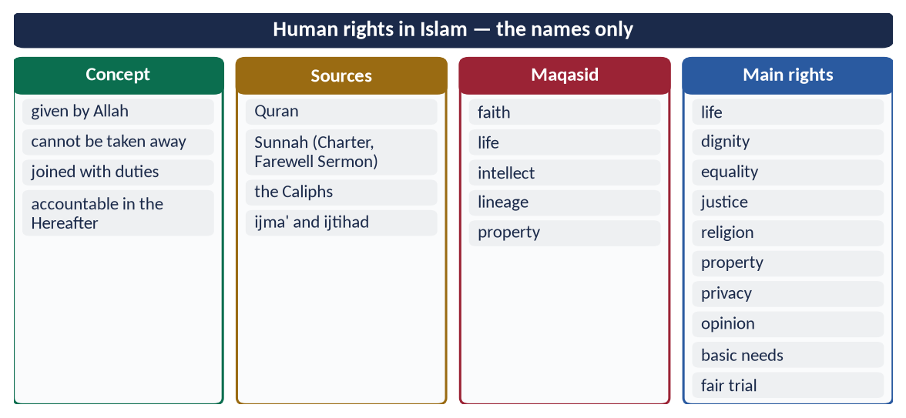
Figure 2 · At a glance — human rights in Islam — the names only. The detail is in the sections above.

Chapter 2 · The Farewell Sermon: The Charter of Human Rights
Asked in 2020 ('the basic document for awakening the conscience of mankind for human rights') and as a note in 2023.

2.1 The occasion
The Farewell Sermon — Khutbat Hajjat al-Wada' (خُطْبَةُ حَجَّةِ الْوَدَاع) — was delivered by the Prophet ﷺ on 9 Dhul Hijjah 10 AH (March 632) at Arafat, before more than a hundred thousand Companions, during his only Hajj. Parts of it were repeated at Mina on 10 Dhul Hijjah. He died about three months later.
✦ QURAN
﴿… ٱلۡيَوۡمَ أَكۡمَلۡتُ لَكُمۡ دِينَكُمۡ وَأَتۡمَمۡتُ عَلَيۡكُمۡ نِعۡمَتِي وَرَضِيتُ لَكُمُ ٱلۡإِسۡلَٰمَ دِينٗاۚ …﴾
“This day I have perfected for you your religion, completed My favour upon you, and approved for you Islam as religion.” (Al-Ma'idah, Quran)
➜ 'This day I have perfected your religion for you' — revealed at Arafat on that day: the sermon stands at the completion of the religion.

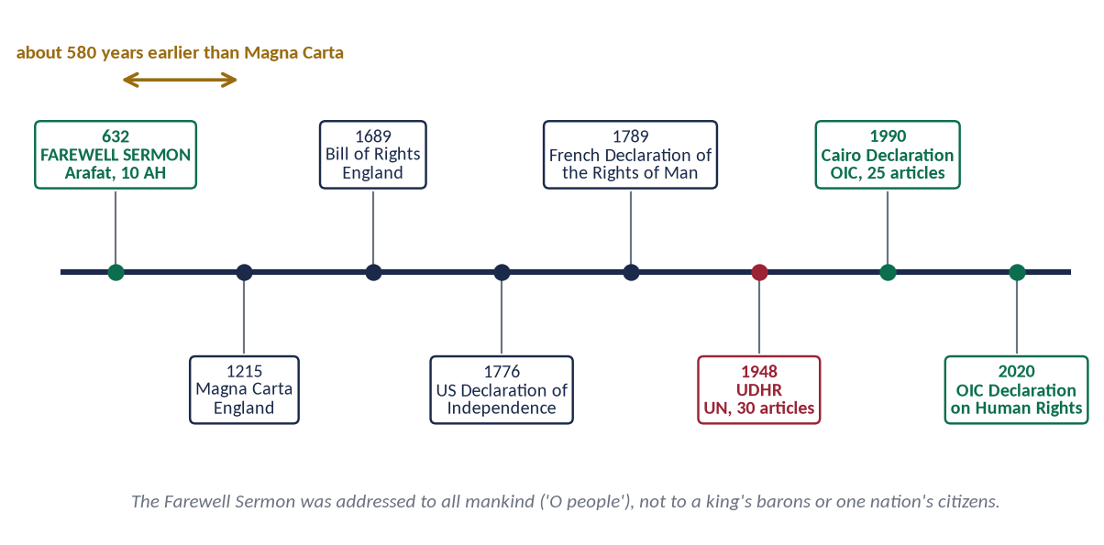
Figure 3 · The Farewell Sermon and the later charters of human rights.

2.2 The main declarations — each a human right
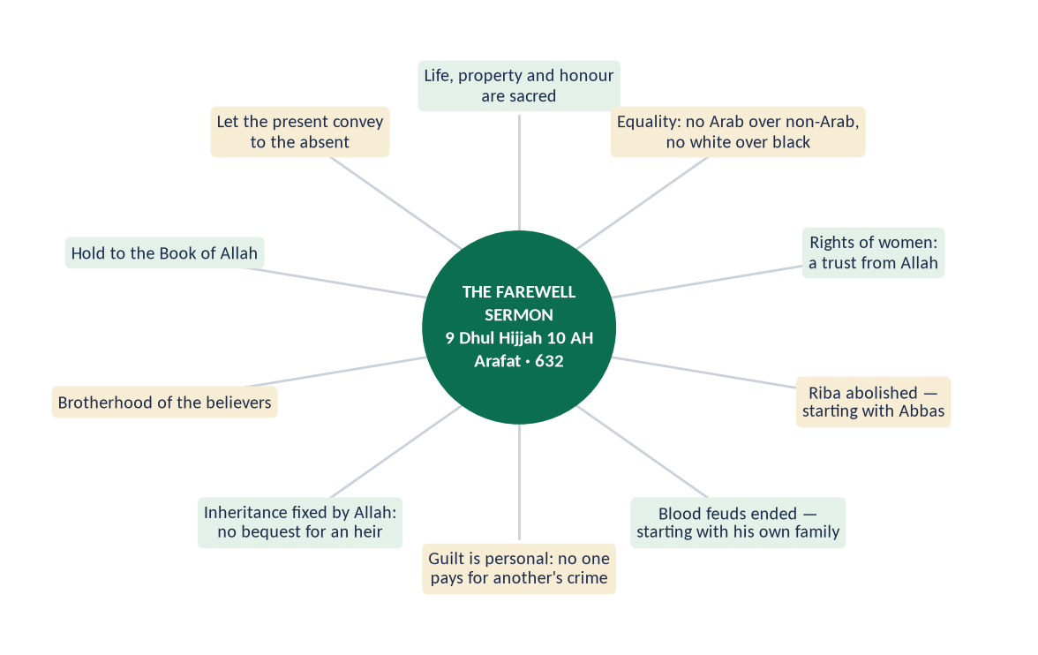
Figure 4 · The ten declarations of the Farewell Sermon.

(1) Sanctity of life, property and honour
✦ HADITH
فَإِنَّ دِمَاءَكُمْ وَأَمْوَالَكُمْ وَأَعْرَاضَكُمْ عَلَيْكُمْ حَرَامٌ، كَحُرْمَةِ يَوْمِكُمْ هَذَا، فِي شَهْرِكُمْ هَذَا، فِي بَلَدِكُمْ هَذَا
“Your lives, your property and your honour are sacred to one another, like the sanctity of this day of yours, in this month of yours, in this city of yours.” (Al-Bukhari)
➜ The right to life, property and honour — the first three rights of every charter.

(2) Equality of all human beings
✦ FROM THE SIRAH
يَا أَيُّهَا النَّاسُ، أَلَا إِنَّ رَبَّكُمْ وَاحِدٌ، وَإِنَّ أَبَاكُمْ وَاحِدٌ، أَلَا لَا فَضْلَ لِعَرَبِيٍّ عَلَى عَجَمِيٍّ، وَلَا لِعَجَمِيٍّ عَلَى عَرَبِيٍّ، وَلَا لِأَحْمَرَ عَلَى أَسْوَدَ، وَلَا أَسْوَدَ عَلَى أَحْمَرَ، إِلَّا بِالتَّقْوَى
“O people, your Lord is one and your father is one. No Arab is superior to a non-Arab, nor a non-Arab to an Arab, nor a white to a black, nor a black to a white — except by taqwa.” (Musnad Ahmad (the Farewell Sermon))
➜ The abolition of racism, 1,300 years before the civil-rights movement.

(3) The rights of women
✦ HADITH
فَاتَّقُوا اللَّهَ فِي النِّسَاءِ، فَإِنَّكُمْ أَخَذْتُمُوهُنَّ بِأَمَانِ اللَّهِ
“Fear Allah concerning women, for you have taken them as a trust from Allah.” (Muslim)
➜ Women are a trust (amanah); their maintenance and kind treatment are rights.

(4) Abolition of riba — economic justice
✦ HADITH
وَرِبَا الْجَاهِلِيَّةِ مَوْضُوعٌ، وَأَوَّلُ رِبًا أَضَعُ رِبَانَا رِبَا عَبَّاسِ بْنِ عَبْدِ الْمُطَّلِبِ
“The riba of the Jahiliyyah is abolished, and the first riba I abolish is our own — the riba of Abbas ibn Abd al-Muttalib.” (Muslim)
➜ The end of exploitation, beginning with his own uncle.

(5) Abolition of blood feuds
✦ HADITH
وَدِمَاءُ الْجَاهِلِيَّةِ مَوْضُوعَةٌ، وَإِنَّ أَوَّلَ دَمٍ أَضَعُ مِنْ دِمَائِنَا دَمُ ابْنِ رَبِيعَةَ بْنِ الْحَارِثِ
“The blood-claims of the Jahiliyyah are abolished, and the first I abolish is that of Ibn Rabi'ah ibn al-Harith.” (Muslim)
➜ Rule of law replaces private revenge — starting with his own family.

(6) Personal responsibility
✦ HADITH
أَلَا لَا يَجْنِي جَانٍ إِلَّا عَلَى نَفْسِهِ
“No offender is responsible except for his own offence.” (Al-Tirmidhi and Ibn Majah)
➜ No collective punishment — no son pays for his father's crime.

(7) Rights of inheritance
✦ HADITH
إِنَّ اللَّهَ قَدْ أَعْطَى كُلَّ ذِي حَقٍّ حَقَّهُ، فَلَا وَصِيَّةَ لِوَارِثٍ
“Allah has given every rightful person his right, so there is no bequest for an heir.” (Abu Dawud and Al-Tirmidhi)
➜ Shares are fixed by Allah — no one can cut an heir out.

(8) Rights of servants and the weak
He told them to feed their servants from what they eat and clothe them from what they wear (Ahmad; the same in Al-Bukhari).

(9) Brotherhood and the rule of the Book
✦ HADITH
وَقَدْ تَرَكْتُ فِيكُمْ مَا لَنْ تَضِلُّوا بَعْدَهُ إِنِ اعْتَصَمْتُمْ بِهِ: كِتَابَ اللَّهِ
“I have left among you that which, if you hold fast to it, you will never go astray: the Book of Allah.” (Muslim)
➜ Law above persons — the constitution of the Ummah.

(10) Accountability and conveying the message
✦ HADITH
لِيُبَلِّغِ الشَّاهِدُ الْغَائِبَ
“Let the one who is present convey to the one who is absent.” (Al-Bukhari)
➜ The sermon is for all people of all times. He asked, 'Have I conveyed?' and they said 'Yes'; he said, 'O Allah, bear witness.'

2.3 Why it is 'the basic document for the awakening of the conscience of mankind'
- (a) Universal address: 'O people' — not 'O Arabs' or 'O Muslims'.
- (b) Earliest: about 580 years before Magna Carta (1215) and 1,316 years before the UDHR (1948).
- (c) Practical: declared by a ruler who enforced it first on his own family — Abbas's riba, Rabi'ah's blood.
- (d) Conscience, not only law: it ties rights to fear of Allah — 'fear Allah concerning women' — the inner police of every heart.
- (e) Complete: life, property, honour, equality, women, economy, justice, inheritance, the weak.
Right | Farewell Sermon (632) | UDHR (1948)
Life and security | 'Your lives are sacred' | Article 3
Property | 'Your property is sacred' | Article 17
Honour, reputation | 'Your honour is sacred' | Article 12
Equality, no racism | 'No Arab over non-Arab…' | Articles 1, 2
Women's rights | 'Fear Allah concerning women' | Article 16
Personal responsibility | 'No offender except for himself' | Article 11
Economic justice | Riba abolished | Articles 22–25

✦ SCHOLARLY VIEW
Allama Muhammad Iqbal · The Reconstruction of Religious Thought in Islam
Iqbal described the essence of Islam as spiritual democracy — the equality and freedom of all human beings under one God — which the Prophet ﷺ declared and practised.
➜ The sermon is spiritual democracy in action.

REMEMBER · THE SERMON IN SIX WORDS
Life · Property · Honour · Equality · Women · Justice. Any sermon answer can be built on these six, each with its Arabic line.

Chapter 3 · Islam and the UDHR: A Comparative and Critical Analysis
Asked in 2026: 'a comparative and critical analysis of the human rights granted by Islam with those enshrined in the UDHR'.

3.1 The UDHR — the facts
- Adopted: 10 December 1948 by the UN General Assembly in Paris (Resolution 217 A) — now Human Rights Day.
- Content: a preamble and 30 articles — civil and political rights (Articles 3–21), economic, social and cultural rights (Articles 22–27), and duties and limits (Articles 29–30).
- Vote: 48 in favour, none against, 8 abstentions (the Soviet bloc, South Africa and Saudi Arabia). Pakistan voted in favour.
- Status: a declaration, not a treaty — morally strong, legally non-binding. It was later given legal form in the two Covenants of 1966 (ICCPR and ICESCR).
- Background: the horrors of the Second World War and the Holocaust.

3.2 The Muslim documents
- The Farewell Sermon (632) — the first charter.
- The Universal Islamic Declaration of Human Rights (1981, Islamic Council of Europe).
- The Cairo Declaration on Human Rights in Islam (1990, OIC — 25 articles): all rights subject to the Shari'ah.
- The OIC Declaration on Human Rights (2020) — a revised version of the Cairo Declaration.
- The Constitution of Pakistan (1973) — Chapter 1 of Part II, Fundamental Rights, Articles 8–28.

3.3 Where Islam and the UDHR agree
Right | Islam | UDHR
Dignity of every human | Al-Isra 70 | Preamble; Article 1
Equality, no discrimination | Al-Hujurat 13; Farewell Sermon | Articles 1, 2, 7
Life, liberty, security | Al-Ma'idah 32 | Article 3
No torture | Prophetic ban on mutilation and torture | Article 5
Fair trial; innocent until proven guilty | Al-Hujurat 6; 'evidence is on the claimant' (Al-Tirmidhi) | Articles 10, 11
Privacy | An-Nur 27; Al-Hujurat 12 | Article 12
Asylum | At-Tawbah 6 | Article 14
Property | An-Nisa 29 | Article 17
Social security and work | Zakat; 'give the worker his wage' (Ibn Majah) | Articles 22, 23
Education | 'Seeking knowledge is obligatory' (Ibn Majah) | Article 26

3.4 Where they differ — the comparative analysis

(1) The source of rights
- UDHR: human agreement — 'inherent dignity' without naming its source; what humans grant, humans can change.
- Islam: Allah — rights are part of revelation; no state can withdraw them.

(2) Rights and duties
- UDHR: a charter of rights; duties appear only in Article 29.
- Islam: rights and duties together — every right is someone's duty (parents–children, ruler–ruled, husband–wife).

(3) The enforcement mechanism
- UDHR: non-binding; depends on states and the Security Council, where five permanent members hold a veto.
- Islam: enforced by conscience (taqwa), the state and accountability in the Hereafter — the rights of people are not forgiven by Allah until the wronged forgive.

(4) The scope
- UDHR: human beings, now.
- Islam: also the unborn (no abortion without cause), the dead (dignity of the corpse), animals, the environment, and future generations (inheritance, no waste).
✦ HADITH
كَسْرُ عَظْمِ الْمَيِّتِ كَكَسْرِهِ حَيًّا
“Breaking the bone of a dead person is like breaking it while he is alive.” (Abu Dawud)
➜ Dignity after death.

(5) Individual and society
- UDHR: mainly individual freedom.
- Islam: the individual within family and society — the family is a sacred institution, not only a private choice.

(6) The limits of freedom
- UDHR: limits only by law, for others' rights, public order and morality (Article 29(2)).
- Islam: freedom within the limits of Allah (hudud Allah) — no freedom to harm oneself, blaspheme or spread indecency.

(7) The points of tension
Most Muslim states entered reservations on two articles: Article 16 (marriage 'without any limitation due to … religion') and Article 18 (freedom to 'change' one's religion). Islam affirms freedom of belief — 'no compulsion' — but places marriage and apostasy within its own family and public law; answer this point calmly and factually.

3.5 The critical analysis

(1) Criticism of the UDHR and its practice
- (a) Not truly universal in origin: only 58 states were UN members in 1948; most of Africa and Asia were still colonies and had no voice in drafting it.
- (b) Double standards: rights are enforced selectively — Kashmir, Palestine and Gaza show the rights of some peoples ignored while others are defended.
- (c) The veto: five powers can block action on any violation.
- (d) Secular individualism: freedom without moral limits has weakened the family and produced loneliness, addiction and family breakdown in many societies.
- (e) Rights without duties: a culture of claims without responsibility.

(2) Honest self-criticism of the Muslim world
- (a) The gap between text and practice: denial of women's inheritance, honour killings, forced marriages, child labour, mistreatment of minorities, torture in custody — all against Islam, yet found in Muslim societies.
- (b) Authoritarian rule: the right to criticise rulers — 'a word of justice before a tyrant' — is often denied.
- (c) Weak implementation of the Cairo and OIC declarations.
✦ SCHOLARLY VIEW
Allama Muhammad Iqbal · The Reconstruction of Religious Thought in Islam
Iqbal called on Muslims to rediscover the spirit of Islam — human equality, freedom and responsibility — and show it to the world in practice, rather than only claiming it.
➜ The strongest answer to the West is Muslim practice.

(3) The verdict
The UDHR is a great human achievement that agrees with Islam on most rights; Islam gives these rights a firmer foundation (Allah), a fuller scope (family, the unborn, the dead, the environment), a balance of rights and duties, and a moral enforcement that no declaration can give. But the Islamic claim is proved only when Muslim states practise it.
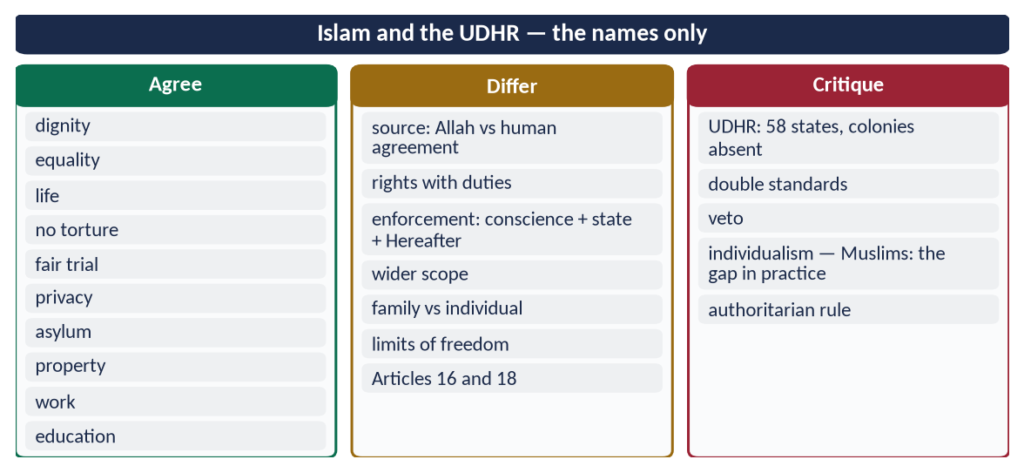
Figure 5 · At a glance — islam and the UDHR — the names only. The detail is in the sections above.

Chapter 4 · Human Dignity and Equality: Men and Women, Colour, Race and Creed
Asked as 'dignity irrespective of colour, race and creed' (2020) and 'how Islam highlights human dignity and greatness' (2024).

4.1 The sources of human dignity in the Quran

(1) Honoured by Allah
✦ QURAN
﴿وَلَقَدۡ كَرَّمۡنَا بَنِيٓ ءَادَمَ وَحَمَلۡنَٰهُمۡ فِي ٱلۡبَرِّ وَٱلۡبَحۡرِ وَرَزَقۡنَٰهُم مِّنَ ٱلطَّيِّبَٰتِ وَفَضَّلۡنَٰهُمۡ عَلَىٰ كَثِيرٖ مِّمَّنۡ خَلَقۡنَا تَفۡضِيلٗا﴾
“And We have certainly honored the children of Adam and carried them on the land and sea and provided for them of the good things and preferred them over much of what We have created, with [definite] preference.” (Al-Isra, Quran)
➜ 'We have honoured the children of Adam', carried them on land and sea, provided for them and preferred them over much of creation — dignity for every child of Adam, whatever his faith.

(2) Created in the best form
✦ QURAN
﴿لَقَدۡ خَلَقۡنَا ٱلۡإِنسَٰنَ فِيٓ أَحۡسَنِ تَقۡوِيمٖ﴾
“We have certainly created man in the best of stature.” (At-Tin, Quran)
➜ 'We created man in the best of stature.'

(3) The spirit of Allah breathed into him
✦ QURAN
﴿فَإِذَا سَوَّيۡتُهُۥ وَنَفَخۡتُ فِيهِ مِن رُّوحِي فَقَعُواْ لَهُۥ سَٰجِدِينَ﴾
“And when I have proportioned him and breathed into him of My [created] soul, then fall down to him in prostration.” (Al-Hijr, Quran)
➜ 'When I have proportioned him and breathed into him of My spirit, fall down to him in prostration.'

(4) The vicegerent on earth
✦ QURAN
﴿… إِنِّي جَاعِلٞ فِي ٱلۡأَرۡضِ خَلِيفَةٗۖ …﴾
“Indeed, I will make upon the earth a vicegerent (khalifah).” (Al-Baqarah, Quran)
➜ 'I will make upon the earth a vicegerent (khalifah).'

(5) Knowledge given to him
✦ QURAN
﴿وَعَلَّمَ ءَادَمَ ٱلۡأَسۡمَآءَ كُلَّهَا ثُمَّ عَرَضَهُمۡ عَلَى ٱلۡمَلَـٰٓئِكَةِ فَقَالَ أَنۢبِـُٔونِي بِأَسۡمَآءِ هَـٰٓؤُلَآءِ إِن كُنتُمۡ صَٰدِقِينَ﴾
“And He taught Adam the names - all of them. Then He showed them to the angels and said, "Inform Me of the names of these, if you are truthful.” (Al-Baqarah, Quran)
➜ Allah taught Adam the names of all things — knowledge is the basis of human rank.

(6) The angels bowed to him
✦ QURAN
﴿وَإِذۡ قُلۡنَا لِلۡمَلَـٰٓئِكَةِ ٱسۡجُدُواْ لِأٓدَمَ فَسَجَدُوٓاْ إِلَّآ إِبۡلِيسَ أَبَىٰ وَٱسۡتَكۡبَرَ وَكَانَ مِنَ ٱلۡكَٰفِرِينَ﴾
“And [mention] when We said to the angels, "Prostrate before Adam"; so they prostrated, except for Iblees. He refused and was arrogant and became of the disbelievers.” (Al-Baqarah, Quran)
➜ The angels were commanded to prostrate to Adam — the highest honour.

(7) The universe made subservient
✦ QURAN
﴿وَسَخَّرَ لَكُم مَّا فِي ٱلسَّمَٰوَٰتِ وَمَا فِي ٱلۡأَرۡضِ جَمِيعٗا مِّنۡهُۚ إِنَّ فِي ذَٰلِكَ لَأٓيَٰتٖ لِّقَوۡمٖ يَتَفَكَّرُونَ﴾
“And He has subjected to you whatever is in the heavens and whatever is on the earth - all from Him. Indeed in that are signs for a people who give thought.” (Al-Jathiyah, Quran)
➜ He has made subject to you whatever is in the heavens and the earth — man is master of nature, not its slave.

(8) The trust (amanah)
✦ QURAN
﴿إِنَّا عَرَضۡنَا ٱلۡأَمَانَةَ عَلَى ٱلسَّمَٰوَٰتِ وَٱلۡأَرۡضِ وَٱلۡجِبَالِ فَأَبَيۡنَ أَن يَحۡمِلۡنَهَا وَأَشۡفَقۡنَ مِنۡهَا وَحَمَلَهَا ٱلۡإِنسَٰنُۖ إِنَّهُۥ كَانَ ظَلُومٗا جَهُولٗا﴾
“Indeed, we offered the Trust to the heavens and the earth and the mountains, and they declined to bear it and feared it; but man [undertook to] bear it. Indeed, he was unjust and ignorant.” (Al-Ahzab, Quran)
➜ The heavens, the earth and the mountains declined the trust; man accepted it — freedom and responsibility are his greatness.

✦ SCHOLARLY VIEW
Allama Muhammad Iqbal · Bal-e-Jibril; Asrar-e-Khudi
Iqbal's philosophy of khudi (selfhood) teaches that man is the vicegerent of God, whose destiny is to develop his self through faith and action — so great that 'the stars are the dust of his path'.
➜ The poet of human greatness.

4.2 Equality irrespective of colour, race and creed

(1) One origin
✦ QURAN
﴿يَـٰٓأَيُّهَا ٱلنَّاسُ ٱتَّقُواْ رَبَّكُمُ ٱلَّذِي خَلَقَكُم مِّن نَّفۡسٖ وَٰحِدَةٖ وَخَلَقَ مِنۡهَا زَوۡجَهَا وَبَثَّ مِنۡهُمَا رِجَالٗا كَثِيرٗا وَنِسَآءٗۚ …﴾
“O mankind, fear your Lord, who created you from one soul, created from it its mate, and spread from both of them many men and women.” (An-Nisa, Quran)
➜ All mankind was created from one soul — there is no 'higher' race.

✦ HADITH
النَّاسُ بَنُو آدَمَ، وَآدَمُ مِنْ تُرَابٍ
“People are the children of Adam, and Adam was from dust.” (Abu Dawud and Al-Tirmidhi)
➜ One father, one clay — the end of racial pride.

(2) Diversity for recognition, not rank
✦ QURAN
﴿يَـٰٓأَيُّهَا ٱلنَّاسُ إِنَّا خَلَقۡنَٰكُم مِّن ذَكَرٖ وَأُنثَىٰ وَجَعَلۡنَٰكُمۡ شُعُوبٗا وَقَبَآئِلَ لِتَعَارَفُوٓاْۚ إِنَّ أَكۡرَمَكُمۡ عِندَ ٱللَّهِ أَتۡقَىٰكُمۡۚ إِنَّ ٱللَّهَ عَلِيمٌ خَبِيرٞ﴾
“O mankind, indeed We have created you from male and female and made you peoples and tribes that you may know one another. Indeed, the most noble of you in the sight of Allah is the most righteous of you. Indeed, Allah is Knowing and Acquainted.” (Al-Hujurat, Quran)
➜ Nations and tribes exist to know one another; the only measure of honour is taqwa.

✦ QURAN
﴿وَمِنۡ ءَايَٰتِهِۦ خَلۡقُ ٱلسَّمَٰوَٰتِ وَٱلۡأَرۡضِ وَٱخۡتِلَٰفُ أَلۡسِنَتِكُمۡ وَأَلۡوَٰنِكُمۡۚ إِنَّ فِي ذَٰلِكَ لَأٓيَٰتٖ لِّلۡعَٰلِمِينَ﴾
“And of His signs is the creation of the heavens and the earth and the diversity of your languages and your colors. Indeed in that are signs for those of knowledge.” (Ar-Rum, Quran)
➜ The diversity of your languages and colours is among His signs.

(3) Allah looks at hearts, not faces
✦ HADITH
إِنَّ اللَّهَ لَا يَنْظُرُ إِلَى صُوَرِكُمْ وَأَمْوَالِكُمْ، وَلَكِنْ يَنْظُرُ إِلَى قُلُوبِكُمْ وَأَعْمَالِكُمْ
“Allah does not look at your appearance or your wealth, but at your hearts and your deeds.” (Muslim)
➜ Colour and wealth count for nothing.

(4) The Sunnah in practice
- (a) Bilal (RA) — a black former slave from Abyssinia — was chosen to give the adhan from the roof of the Ka'bah at the Conquest of Makkah.
- (b) Abu Dharr (RA) once taunted a man about his black mother. The Prophet ﷺ said:
✦ HADITH
إِنَّكَ امْرُؤٌ فِيكَ جَاهِلِيَّةٌ
“You are a man in whom there is still Jahiliyyah (ignorance).” (Al-Bukhari)
➜ Racism is pre-Islamic ignorance. Abu Dharr then dressed his servant as he dressed himself.

- (c) Salman (RA) the Persian: 'Salman is one of us, the people of the house' (Al-Hakim).
- (d) Usamah ibn Zayd (RA), son of a freed slave, commanded an army that included senior Companions.
- (e) Zayd ibn Harithah (RA), a freed slave, married Zaynab bint Jahsh (RA) of the Quraysh — breaking the barrier of class.

(5) Equality of creed — dignity of non-Muslims
✦ QURAN
﴿لَآ إِكۡرَاهَ فِي ٱلدِّينِۖ قَد تَّبَيَّنَ ٱلرُّشۡدُ مِنَ ٱلۡغَيِّۚ …﴾
“There is no compulsion in religion; the right course has become clear from the wrong.” (Al-Baqarah, Quran)
➜ No compulsion in religion.

✦ QURAN
﴿لَّا يَنۡهَىٰكُمُ ٱللَّهُ عَنِ ٱلَّذِينَ لَمۡ يُقَٰتِلُوكُمۡ فِي ٱلدِّينِ وَلَمۡ يُخۡرِجُوكُم مِّن دِيَٰرِكُمۡ أَن تَبَرُّوهُمۡ وَتُقۡسِطُوٓاْ إِلَيۡهِمۡۚ إِنَّ ٱللَّهَ يُحِبُّ ٱلۡمُقۡسِطِينَ﴾
“Allah does not forbid you from those who do not fight you because of religion and do not expel you from your homes - from being righteous toward them and acting justly toward them. Indeed, Allah loves those who act justly.” (Al-Mumtahanah, Quran)
➜ Kindness and justice to non-Muslims who do not fight you.

He stood for a Jewish funeral: 'Is it not a soul?' (Al-Bukhari and Muslim).

(6) Equality before the law
Hazrat Umar (RA) — when the son of Amr ibn al-As, governor of Egypt, struck an Egyptian commoner, Umar had the Egyptian strike the governor's son in return and said:
✦ SCHOLARLY VIEW
Hazrat Umar Farooq (RA) · Second Rightly-Guided Caliph, to his governor of Egypt
“Since when have you enslaved people when their mothers bore them free?”
➜ Freedom and equality before the law belong to every citizen, 1,100 years before Rousseau's 'Man is born free'.

4.3 Dignity of men and women
✦ QURAN
﴿… أَنِّي لَآ أُضِيعُ عَمَلَ عَٰمِلٖ مِّنكُم مِّن ذَكَرٍ أَوۡ أُنثَىٰۖ بَعۡضُكُم مِّنۢ بَعۡضٖۖ …﴾
“Never will I allow the work of any worker among you to be lost, whether male or female; you are of one another.” (Aal-e-Imran, Quran)
➜ 'I will not allow the work of any worker to be lost, whether male or female; you are of one another.'

✦ QURAN
﴿إِنَّ ٱلۡمُسۡلِمِينَ وَٱلۡمُسۡلِمَٰتِ وَٱلۡمُؤۡمِنِينَ وَٱلۡمُؤۡمِنَٰتِ وَٱلۡقَٰنِتِينَ وَٱلۡقَٰنِتَٰتِ وَٱلصَّـٰدِقِينَ وَٱلصَّـٰدِقَٰتِ وَٱلصَّـٰبِرِينَ وَٱلصَّـٰبِرَٰتِ وَٱلۡخَٰشِعِينَ وَٱلۡخَٰشِعَٰتِ وَٱلۡمُتَصَدِّقِينَ وَٱلۡمُتَصَدِّقَٰتِ وَٱلصَّـٰٓئِمِينَ وَٱلصَّـٰٓئِمَٰتِ وَٱلۡحَٰفِظِينَ فُرُوجَهُمۡ وَٱلۡحَٰفِظَٰتِ وَٱلذَّـٰكِرِينَ ٱللَّهَ كَثِيرٗا وَٱلذَّـٰكِرَٰتِ أَعَدَّ ٱللَّهُ لَهُم مَّغۡفِرَةٗ وَأَجۡرًا عَظِيمٗا﴾
“Indeed, the Muslim men and Muslim women, the believing men and believing women, the obedient men and obedient women, the truthful men and truthful women, the patient men and patient women, the humble men and humble women, the charitable men and charitable women, the fasting men and fasting women, the men who guard their private parts and the women who do so, and the men who remember Allah often and the women who do so - for them Allah has prepared forgiveness and a great reward.” (Al-Ahzab, Quran)
➜ Muslim men and Muslim women, believing men and believing women … the same forgiveness and great reward for both.

✦ HADITH
إِنَّمَا النِّسَاءُ شَقَائِقُ الرِّجَالِ
“Women are the twin halves of men.” (Abu Dawud and Al-Tirmidhi)
➜ Equal in dignity, complementary in roles.

4.4 Dignity protected in every condition
- The poor: charity 'without reminders or injury' (Al-Baqarah 264).
- The criminal: punished, not humiliated; the Prophet ﷺ forbade cursing a man who had been punished for drinking (Al-Bukhari).
- The enemy: no mutilation of the dead (Muslim).
- The dead: 'breaking a dead man's bone is like breaking it alive' (Abu Dawud).
- The servant: 'your servants are your brothers … feed them from what you eat' (Al-Bukhari).
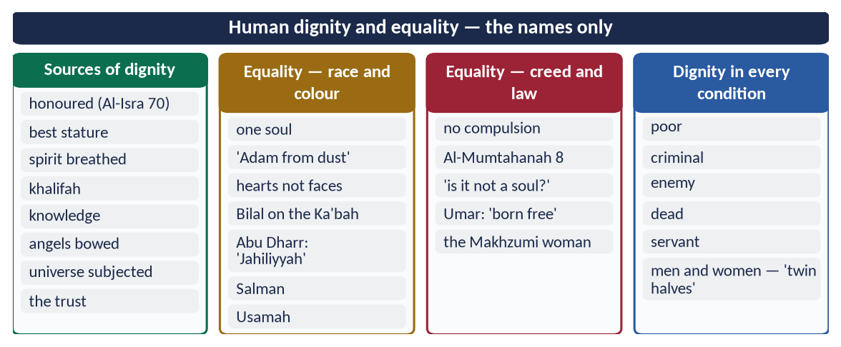
Figure 6 · At a glance — human dignity and equality — the names only. The detail is in the sections above.

4.5 Social justice in an Islamic society (the 2023 note)

(1) Meaning
Social justice — 'adl ijtima'i (عَدْلٌ اجْتِمَاعِي) — means that every member of society receives his due: equal rights before the law, fair opportunity, a share in wealth, and protection of the weak.
✦ QURAN
﴿لَقَدۡ أَرۡسَلۡنَا رُسُلَنَا بِٱلۡبَيِّنَٰتِ وَأَنزَلۡنَا مَعَهُمُ ٱلۡكِتَٰبَ وَٱلۡمِيزَانَ لِيَقُومَ ٱلنَّاسُ بِٱلۡقِسۡطِۖ …﴾
“We sent Our messengers with clear proofs and sent down with them the Book and the Balance, so that people may uphold justice.” (Al-Hadid, Quran)
➜ Messengers were sent with the Book and the Balance so that people may uphold justice — justice is the purpose of prophethood.

✦ QURAN
﴿إِنَّ ٱللَّهَ يَأۡمُرُ بِٱلۡعَدۡلِ وَٱلۡإِحۡسَٰنِ وَإِيتَآيِٕ ذِي ٱلۡقُرۡبَىٰ وَيَنۡهَىٰ عَنِ ٱلۡفَحۡشَآءِ وَٱلۡمُنكَرِ وَٱلۡبَغۡيِۚ يَعِظُكُمۡ لَعَلَّكُمۡ تَذَكَّرُونَ﴾
“Indeed, Allah orders justice and good conduct and giving to relatives and forbids immorality and bad conduct and oppression. He admonishes you that perhaps you will be reminded.” (An-Nahl, Quran)
➜ Allah commands justice ('adl), excellence (ihsan) and giving to relatives.

(2) The pillars of social justice in Islam
- (a) Equality before law — 'if Fatimah stole…'.
- (b) Circulation of wealth — Zakat, Sadaqah, inheritance, the ban on hoarding and riba:
✦ QURAN
﴿… كَيۡ لَا يَكُونَ دُولَةَۢ بَيۡنَ ٱلۡأَغۡنِيَآءِ مِنكُمۡۚ …﴾
“… so that it does not circulate only among the rich among you.” (Al-Hashr, Quran)
➜ So that wealth does not circulate only among the rich.

- (c) Right of the needy — 'in their wealth is a right for the one who asks and the deprived' (Adh-Dhariyat 19).
- (d) Dignity of labour — 'give the worker his wage before his sweat dries' (Ibn Majah).
- (e) Accountability of rulers — a Bedouin asked Umar (RA) in public how he got a long shirt from the cloth given to all; his son explained he had given his share.
- (f) State welfare — Umar (RA) gave stipends even to newborns and to a poor old Jew from the treasury (Abu Yusuf, Kitab al-Kharaj); under Umar ibn Abd al-Aziz no one could be found to take Zakat.

(3) Pakistan
Article 3 (elimination of exploitation), 37 (social justice and eradication of social evils) and 38 (well-being of the people) — the Constitution copies the ideal; the gap is implementation: about 40 percent of Pakistanis live below the poverty line (World Bank, 2024–25).

Chapter 5 · The Status of Women: Before Islam and in Islam
Asked as 'status of women in Islam' within human rights (2022) and 'better rights to men and women than all other religions' (2021).

5.1 Women before Islam — the world of the 7th century
Society | The condition of women
Pre-Islamic Arabia | Baby girls buried alive; no inheritance; widows inherited like property by the husband's heirs; unlimited marriages and divorces.
Greece | Aristotle called the woman an incomplete man; women were confined to the home, without education or citizenship.
Rome | Under patria potestas the father or husband had near-total power over her person and property.
Persia | Women of the lower classes had few rights; marriage to close relatives was practised among the nobility.
India | Sati — burning of the widow on the husband's pyre (abolished only in 1829); widows could not remarry.
Medieval Europe | Under English common law (coverture), a married woman's property belonged to her husband until the Married Women's Property Acts of 1870 and 1882.

✦ QURAN
﴿وَإِذَا بُشِّرَ أَحَدُهُم بِٱلۡأُنثَىٰ ظَلَّ وَجۡهُهُۥ مُسۡوَدّٗا وَهُوَ كَظِيمٞ ۝ يَتَوَٰرَىٰ مِنَ ٱلۡقَوۡمِ مِن سُوٓءِ مَا بُشِّرَ بِهِۦٓۚ أَيُمۡسِكُهُۥ عَلَىٰ هُونٍ أَمۡ يَدُسُّهُۥ فِي ٱلتُّرَابِۗ أَلَا سَآءَ مَا يَحۡكُمُونَ﴾
“And when one of them is informed of [the birth of] a female, his face becomes dark, and he suppresses grief. He hides himself from the people because of the ill of which he has been informed. Should he keep it in humiliation or bury it in the ground? Unquestionably, evil is what they decide.” (An-Nahl, Quran)
➜ When one of them was told of the birth of a girl, his face darkened — should he keep her in humiliation or bury her in the dust?

✦ QURAN
﴿وَإِذَا ٱلۡمَوۡءُۥدَةُ سُئِلَتۡ ۝ بِأَيِّ ذَنۢبٖ قُتِلَتۡ﴾
“And when the girl [who was] buried alive is asked. For what sin she was killed.” (At-Takwir, Quran)
➜ On the Day of Judgement the girl buried alive will be asked for what sin she was killed.

TRAP · COMPARE PRACTICES, RESPECT RELIGIONS
In a comparison question (2021), compare laws and historical practices, not the faiths' founders or scriptures in a mocking tone. State facts (sati, coverture, the dates when Western women got property and votes) and let them speak. Respect for other religions is itself an Islamic teaching (Al-An'am 108).

5.2 The revolution Islam brought

(1) The same soul — equal in humanity
✦ QURAN
﴿يَـٰٓأَيُّهَا ٱلنَّاسُ ٱتَّقُواْ رَبَّكُمُ ٱلَّذِي خَلَقَكُم مِّن نَّفۡسٖ وَٰحِدَةٖ وَخَلَقَ مِنۡهَا زَوۡجَهَا وَبَثَّ مِنۡهُمَا رِجَالٗا كَثِيرٗا وَنِسَآءٗۚ …﴾
“O mankind, fear your Lord, who created you from one soul, created from it its mate, and spread from both of them many men and women.” (An-Nisa, Quran)
➜ Men and women are created from one soul and its mate.

(2) No blame of woman for the Fall
In the Quran, Adam and Hawwa (Eve) both were tempted, both repented, and both were forgiven (Al-A'raf 23); the woman is not blamed for human sin.
✦ QURAN
﴿قَالَا رَبَّنَا ظَلَمۡنَآ أَنفُسَنَا وَإِن لَّمۡ تَغۡفِرۡ لَنَا وَتَرۡحَمۡنَا لَنَكُونَنَّ مِنَ ٱلۡخَٰسِرِينَ﴾
“They said, "Our Lord, we have wronged ourselves, and if You do not forgive us and have mercy upon us, we will surely be among the losers.” (Al-A'raf, Quran)
➜ They both said: 'Our Lord, we have wronged ourselves; if You do not forgive us … we will be among the losers.'

(3) Equal spiritual reward
✦ QURAN
﴿مَنۡ عَمِلَ صَٰلِحٗا مِّن ذَكَرٍ أَوۡ أُنثَىٰ وَهُوَ مُؤۡمِنٞ فَلَنُحۡيِيَنَّهُۥ حَيَوٰةٗ طَيِّبَةٗۖ وَلَنَجۡزِيَنَّهُمۡ أَجۡرَهُم بِأَحۡسَنِ مَا كَانُواْ يَعۡمَلُونَ﴾
“Whoever does righteousness, whether male or female, while he is a believer - We will surely cause him to live a good life, and We will surely give them their reward [in the Hereafter] according to the best of what they used to do.” (An-Nahl, Quran)
➜ Whoever does good, male or female, while a believer — We will give him a good life and reward.

The same promise is repeated for believing men and women in Al-Ahzab 35 and Aal-e-Imran 195.

(4) Equal in the Hereafter, equal in accountability
The same duties of faith, prayer, fasting, Zakat and Hajj; the same accountability.

5.3 Better rights than other systems — the comparison (2021)
Right | Islam (7th century) | Elsewhere
Right to life | Female infanticide banned (Al-An'am 151) | Infanticide common in many ancient societies
Consent to marriage | Required (Al-Bukhari and Muslim) | Arranged without consent in much of the world
Own property in her name | From the start (An-Nisa 32) | England: 1870–1882
Inheritance | Fixed shares (An-Nisa 7, 11) | Excluded in many laws until the 19th–20th centuries
Keep her own name | Yes — never takes the husband's name by law | Takes the husband's name in many cultures
Right to divorce | Khula' (Al-Baqarah 229) | Divorce hardly possible in many systems until the 20th century
Remarriage of widows | Encouraged — the Prophet ﷺ married widows | Forbidden in some traditions
Education | 'Obligatory on every Muslim' (Ibn Majah) | Universities closed to women until the 19th century
Vote / public voice | Women gave the pledge (bay'ah) — Al-Mumtahanah 12 | UK 1918/1928; USA 1920; Switzerland 1971

✦ SCHOLARLY VIEW
Annie Besant · The Life and Teachings of Muhammad (1932)
Besant, a British reformer, wrote that the Muslim woman had legal rights over her property from the beginning — long before English women won them — and judged that in this respect she was freer under Islamic law than women in the West of her day.
➜ A Western reformer's verdict.

EXAMINER'S EYE · 'MEN AND WOMEN' IN 2021
The 2021 question said 'better rights to men and women' — include a short section on men's rights too: freedom from racial and class slavery, dignity of labour, right to property and justice, and rights against women (respect, obedience in lawful matters within marriage, care in old age). An answer only on women loses a limb.

Chapter 6 · Women as Daughter, Wife, Mother and Citizen
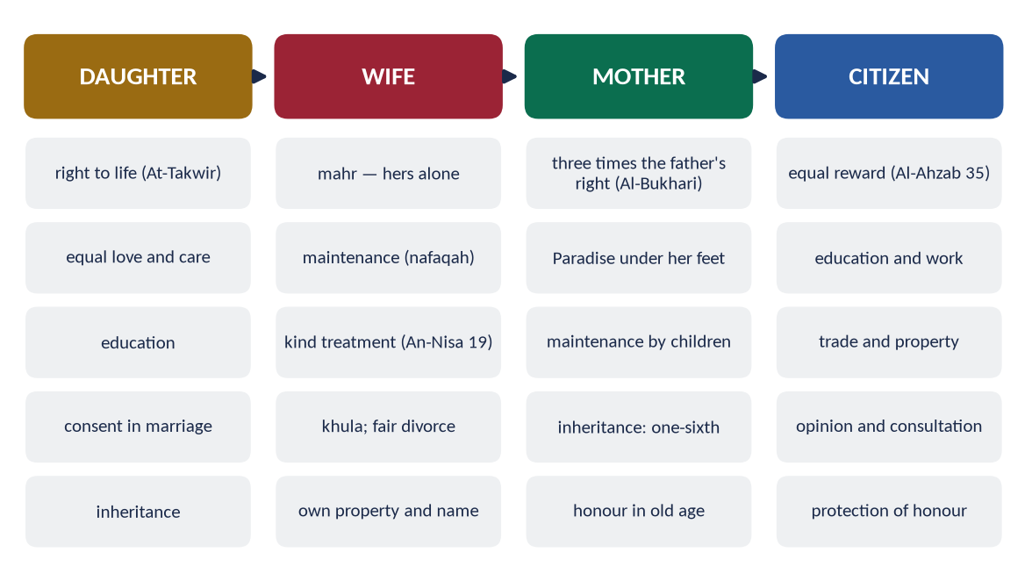
Figure 7 · The rights of the woman at every stage of her life.

6.1 As a daughter

(1) The right to life
✦ QURAN
﴿… وَلَا تَقۡتُلُوٓاْ أَوۡلَٰدَكُم مِّنۡ إِمۡلَٰقٖ نَّحۡنُ نَرۡزُقُكُمۡ وَإِيَّاهُمۡۖ …﴾
“Do not kill your children out of poverty; We provide for you and for them.” (Al-An'am, Quran)
➜ 'Do not kill your children out of poverty; We provide for you and for them.'

(2) Good news, not grief
✦ QURAN
﴿لِّلَّهِ مُلۡكُ ٱلسَّمَٰوَٰتِ وَٱلۡأَرۡضِۚ يَخۡلُقُ مَا يَشَآءُۚ يَهَبُ لِمَن يَشَآءُ إِنَٰثٗا وَيَهَبُ لِمَن يَشَآءُ ٱلذُّكُورَ ۝ أَوۡ يُزَوِّجُهُمۡ ذُكۡرَانٗا وَإِنَٰثٗاۖ وَيَجۡعَلُ مَن يَشَآءُ عَقِيمًاۚ إِنَّهُۥ عَلِيمٞ قَدِيرٞ﴾
“To Allah belongs the dominion of the heavens and the earth; He creates what he wills. He gives to whom He wills female [children], and He gives to whom He wills males. Or He makes them [both] males and females, and He renders whom He wills barren. Indeed, He is Knowing and Competent.” (Ash-Shura, Quran)
➜ Allah gives daughters to whom He wills, sons to whom He wills — daughters are a gift, and in the verse they are mentioned first.

(3) Paradise for raising daughters
✦ HADITH
مَنْ عَالَ جَارِيَتَيْنِ حَتَّى تَبْلُغَا، جَاءَ يَوْمَ الْقِيَامَةِ أَنَا وَهُوَ — وَضَمَّ أَصَابِعَهُ
“Whoever raises two daughters until they grow up, he and I will come on the Day of Resurrection like this — and he joined his fingers.” (Muslim)
➜ The Prophet's ﷺ company for a good father of daughters.

✦ HADITH
مَنِ ابْتُلِيَ مِنْ هَذِهِ الْبَنَاتِ بِشَيْءٍ فَأَحْسَنَ إِلَيْهِنَّ كُنَّ لَهُ سِتْرًا مِنَ النَّارِ
“Whoever is tested with daughters and treats them well, they will be a shield for him from the Fire.” (Al-Bukhari and Muslim)
➜ Daughters are a path to Paradise, not a burden.

(4) Equal love and justice among children
✦ HADITH
اتَّقُوا اللَّهَ وَاعْدِلُوا بَيْنَ أَوْلَادِكُمْ
“Fear Allah and be just between your children.” (Al-Bukhari and Muslim)
➜ No preference of sons over daughters in gifts and care.

(5) Education and upbringing
The Prophet ﷺ gave women a separate day for learning (Al-Bukhari); Hazrat Aishah (RA) became a teacher of the senior Companions.

(6) Consent in marriage
✦ HADITH
لَا تُنْكَحُ الْأَيِّمُ حَتَّى تُسْتَأْمَرَ، وَلَا تُنْكَحُ الْبِكْرُ حَتَّى تُسْتَأْذَنَ
“A previously married woman is not married until she is consulted, and a virgin is not married until her permission is sought.” (Al-Bukhari and Muslim)
➜ When Khansa bint Khidam was married against her will, the Prophet ﷺ annulled the marriage (Al-Bukhari).

(7) Inheritance
✦ QURAN
﴿لِّلرِّجَالِ نَصِيبٞ مِّمَّا تَرَكَ ٱلۡوَٰلِدَانِ وَٱلۡأَقۡرَبُونَ وَلِلنِّسَآءِ نَصِيبٞ مِّمَّا تَرَكَ ٱلۡوَٰلِدَانِ وَٱلۡأَقۡرَبُونَ مِمَّا قَلَّ مِنۡهُ أَوۡ كَثُرَۚ نَصِيبٗا مَّفۡرُوضٗا﴾
“For men is a share of what the parents and close relatives leave, and for women is a share of what the parents and close relatives leave, be it little or much - an obligatory share.” (An-Nisa, Quran)
➜ For women is a share of what parents and relatives leave — little or much, an obligatory share.

(8) The model father
He stood when Fatimah (RA) entered, kissed her, and seated her in his place.
✦ HADITH
فَاطِمَةُ بَضْعَةٌ مِنِّي، فَمَنْ أَغْضَبَهَا أَغْضَبَنِي
“Fatimah is a part of me; whoever angers her angers me.” (Al-Bukhari)
➜ A daughter's honour is the father's honour.

6.2 How the rights of daughters are denied by Muslims today (the 2023 limb)
Denial | Reality in society | Islamic ruling
Sex-selective neglect | Grief at a girl's birth; less food and health care for girls | Al-Nahl 58–59 condemns it
Education | About 26 million children out of school in Pakistan — a majority of them girls | Knowledge is obligatory for all
Forced and early marriage | Marriages without consent; vani and swara (girls given to settle feuds) | Consent required; Khansa's marriage annulled
Denial of inheritance | Daughters pressured to 'gift' their share to brothers | An-Nisa 7: an obligatory share
Dowry (jahez) burden | Parents in debt; girls unmarried for lack of dowry | Mahr is the husband's duty; jahez is not required
Honour killing | Hundreds of cases a year (HRCP) | Murder — Al-Ma'idah 32
Marriage to the Quran | Rare, to keep property in the family | A crime under Pakistani law (2011)

Pakistani law against these practices
- Prevention of Anti-Women Practices (Criminal Law Amendment) Act, 2011 — PPC 310A (giving a girl in badla-e-sulh, vani, swara), 498A (depriving women of inheritance), 498B (forced marriage), 498C (marriage with the Quran).
- Criminal Law (Amendment) (Offences in the Name or Pretext of Honour) Act, 2016 — honour killing no longer escapes punishment through pardon.
- Enforcement of Women's Property Rights Act, 2020 — speedy remedy for women denied property.
- Constitution: Articles 25 (no discrimination on the basis of sex), 34 (full participation of women), 35 (protection of the family, mother and child).
PAKISTAN · THE HONEST ADMISSION
These denials come from tribal custom and greed, not from Islam. The examiner asked 'how these are denied by Muslims' — say it plainly, then show that Islam is the cure, not the cause.

6.3 As a wife

(1) Marriage by her consent, with mahr
✦ QURAN
﴿وَءَاتُواْ ٱلنِّسَآءَ صَدُقَٰتِهِنَّ نِحۡلَةٗۚ فَإِن طِبۡنَ لَكُمۡ عَن شَيۡءٖ مِّنۡهُ نَفۡسٗا فَكُلُوهُ هَنِيٓـٔٗا مَّرِيٓـٔٗا﴾
“And give the women [upon marriage] their [bridal] gifts graciously. But if they give up willingly to you anything of it, then take it in satisfaction and ease.” (An-Nisa, Quran)
➜ 'Give the women their mahr as a free gift.'

(2) Maintenance
✦ QURAN
﴿أَسۡكِنُوهُنَّ مِنۡ حَيۡثُ سَكَنتُم مِّن وُجۡدِكُمۡ وَلَا تُضَآرُّوهُنَّ لِتُضَيِّقُواْ عَلَيۡهِنَّۚ …﴾
“Lodge them where you live, according to your means, and do not harm them so as to make life hard for them.” (At-Talaq, Quran)
➜ 'Lodge them where you live, according to your means, and do not harm them.'

✦ QURAN
﴿وَٱلۡوَٰلِدَٰتُ يُرۡضِعۡنَ أَوۡلَٰدَهُنَّ حَوۡلَيۡنِ كَامِلَيۡنِۖ لِمَنۡ أَرَادَ أَن يُتِمَّ ٱلرَّضَاعَةَۚ وَعَلَى ٱلۡمَوۡلُودِ لَهُۥ رِزۡقُهُنَّ وَكِسۡوَتُهُنَّ بِٱلۡمَعۡرُوفِۚ …﴾
“Mothers shall breastfeed their children two complete years …; and upon the father is their provision and their clothing according to what is acceptable.” (Al-Baqarah, Quran)
➜ Upon the father is their provision and clothing according to what is acceptable.

(3) Kind treatment
✦ QURAN
﴿… وَعَاشِرُوهُنَّ بِٱلۡمَعۡرُوفِۚ …﴾
“And live with them in kindness.” (An-Nisa, Quran)
➜ 'Live with them in kindness.'

✦ HADITH
أَكْمَلُ الْمُؤْمِنِينَ إِيمَانًا أَحْسَنُهُمْ خُلُقًا، وَخِيَارُكُمْ خِيَارُكُمْ لِنِسَائِهِمْ
“The most perfect believer in faith is the best in character, and the best of you are those who are best to their wives.” (Al-Tirmidhi)
➜ Goodness is measured at home.

✦ HADITH
اسْتَوْصُوا بِالنِّسَاءِ خَيْرًا
“Take good care of women.” (Al-Bukhari and Muslim)
➜ His repeated command.

(4) Mutual rights
✦ QURAN
﴿… وَلَهُنَّ مِثۡلُ ٱلَّذِي عَلَيۡهِنَّ بِٱلۡمَعۡرُوفِۚ وَلِلرِّجَالِ عَلَيۡهِنَّ دَرَجَةٞۗ …﴾
“And women have rights similar to their obligations, according to what is reasonable; and men have a degree over them.” (Al-Baqarah, Quran)
➜ Women have rights like their obligations, according to what is reasonable.

✦ QURAN
﴿… هُنَّ لِبَاسٞ لَّكُمۡ وَأَنتُمۡ لِبَاسٞ لَّهُنَّۗ …﴾
“They are clothing for you and you are clothing for them.” (Al-Baqarah, Quran)
➜ 'They are clothing for you and you are clothing for them' — protection, comfort and closeness on both sides.

(5) 'Qawwamun' — responsibility, not superiority
✦ QURAN
﴿ٱلرِّجَالُ قَوَّـٰمُونَ عَلَى ٱلنِّسَآءِ بِمَا فَضَّلَ ٱللَّهُ بَعۡضَهُمۡ عَلَىٰ بَعۡضٖ وَبِمَآ أَنفَقُواْ مِنۡ أَمۡوَٰلِهِمۡۚ …﴾
“Men are the protectors and maintainers of women, because Allah has given some of them more than others and because they spend from their wealth.” (An-Nisa, Quran)
➜ Men are qawwamun — protectors and maintainers — because they spend from their wealth.

The word describes a duty of care and maintenance, not a licence for harshness. The Prophet ﷺ never struck a woman or a servant (Muslim, from Hazrat Aishah RA), and he said of men who beat their wives, 'those are not the best of you' (Abu Dawud).

(6) Right to leave an unhappy marriage
✦ QURAN
﴿ٱلطَّلَٰقُ مَرَّتَانِۖ فَإِمۡسَاكُۢ بِمَعۡرُوفٍ أَوۡ تَسۡرِيحُۢ بِإِحۡسَٰنٖۗ …﴾
“Divorce is twice; then either keep her in an acceptable manner or release her with kindness.” (Al-Baqarah, Quran)
➜ Divorce is twice; then keep her in kindness or release her with good treatment; the wife may free herself (khula').

The wife of Thabit ibn Qays came to the Prophet ﷺ; she could not live with him, and he allowed her khula' on returning his garden (Al-Bukhari).

(7) Her own property, name and identity
She keeps her own name, her own property and her own earnings; the husband has no right to them.

6.4 As a mother
✦ QURAN
﴿وَقَضَىٰ رَبُّكَ أَلَّا تَعۡبُدُوٓاْ إِلَّآ إِيَّاهُ وَبِٱلۡوَٰلِدَيۡنِ إِحۡسَٰنًاۚ إِمَّا يَبۡلُغَنَّ عِندَكَ ٱلۡكِبَرَ أَحَدُهُمَآ أَوۡ كِلَاهُمَا فَلَا تَقُل لَّهُمَآ أُفّٖ وَلَا تَنۡهَرۡهُمَا وَقُل لَّهُمَا قَوۡلٗا كَرِيمٗا﴾
“Your Lord has decreed that you worship none but Him, and that you be good to parents. If one or both of them reach old age with you, do not say to them even 'uff', nor repel them, but speak to them a noble word.” (Al-Isra, Quran)
➜ Be good to parents; do not say even 'uff' to them in old age.

✦ QURAN
﴿وَوَصَّيۡنَا ٱلۡإِنسَٰنَ بِوَٰلِدَيۡهِ حَمَلَتۡهُ أُمُّهُۥ وَهۡنًا عَلَىٰ وَهۡنٖ وَفِصَٰلُهُۥ فِي عَامَيۡنِ أَنِ ٱشۡكُرۡ لِي وَلِوَٰلِدَيۡكَ إِلَيَّ ٱلۡمَصِيرُ﴾
“And We have enjoined upon man [care] for his parents. His mother carried him, [increasing her] in weakness upon weakness, and his weaning is in two years. Be grateful to Me and to your parents; to Me is the [final] destination.” (Luqman, Quran)
➜ His mother carried him in weakness upon weakness — the Quran singles out the mother's sacrifice.

✦ HADITH
أُمُّكَ، ثُمَّ أُمُّكَ، ثُمَّ أُمُّكَ، ثُمَّ أَبُوكَ
“Your mother, then your mother, then your mother, then your father.” (Al-Bukhari and Muslim)
➜ Asked who most deserves good company, he named the mother three times.

✦ HADITH
فَالْزَمْهَا، فَإِنَّ الْجَنَّةَ تَحْتَ رِجْلَيْهَا
“Stay with her, for Paradise is beneath her feet.” (Al-Nasa'i and Ibn Majah)
➜ Service of the mother before jihad.

6.5 As a citizen and member of society
- (a) Worship and knowledge: women prayed in the Prophet's ﷺ mosque; Hazrat Aishah narrated over 2,200 hadith.
- (b) Economic life: Khadijah (RA) was a leading merchant of Makkah; Umar (RA) appointed Al-Shifa bint Abdullah to supervise the market (Ibn Abd al-Barr).
- (c) Political voice: women gave the pledge (bay'ah) to the Prophet ﷺ (Al-Mumtahanah 12); Umm Salamah's advice at Hudaybiyyah resolved the crisis (Al-Bukhari).
- (d) Service in crisis: Rufaydah al-Aslamiyyah ran a field tent for the wounded; Nusaybah (Umm Umarah) defended the Prophet ﷺ at Uhud.
- (e) Protection of honour: a false accusation of unchastity carries eighty lashes (An-Nur 4).
✦ QURAN
﴿وَٱلۡمُؤۡمِنُونَ وَٱلۡمُؤۡمِنَٰتُ بَعۡضُهُمۡ أَوۡلِيَآءُ بَعۡضٖۚ يَأۡمُرُونَ بِٱلۡمَعۡرُوفِ وَيَنۡهَوۡنَ عَنِ ٱلۡمُنكَرِ …﴾
“The believing men and believing women are allies of one another; they enjoin what is right and forbid what is wrong.” (At-Tawbah, Quran)
➜ 'The believing men and believing women are allies of one another; they enjoin good and forbid evil' — partnership in public life.

✦ SCHOLARLY VIEW
Quaid-e-Azam Muhammad Ali Jinnah · Speech at Aligarh, 1944
Jinnah said that no nation can rise to the height of glory unless its women are side by side with its men.
➜ The founder of Pakistan on women's role.

✦ SCHOLARLY VIEW
Allama Muhammad Iqbal · Zarb-e-Kalim
'Wujood-e-zan se hai tasveer-e-kainat mein rang' — the colour in the picture of the universe comes from woman.
➜ The poet's tribute.

Chapter 7 · The Economic Rights of Women: Mahr, Nafaqah and Inheritance
Asked in 2017: 'a comprehensive note on the right of inheritance granted to women by Islam'.

7.1 The principle — a woman's wealth is her own
✦ QURAN
﴿… لِّلرِّجَالِ نَصِيبٞ مِّمَّا ٱكۡتَسَبُواْۖ وَلِلنِّسَآءِ نَصِيبٞ مِّمَّا ٱكۡتَسَبۡنَۚ …﴾
“For men is a share of what they have earned, and for women is a share of what they have earned.” (An-Nisa, Quran)
➜ 'For men is a share of what they have earned, and for women is a share of what they have earned.'

She may own, earn, trade, invest, give and bequeath in her own name; no father, husband or son may take it.

7.2 Mahr — the bridal gift
✦ QURAN
﴿وَءَاتُواْ ٱلنِّسَآءَ صَدُقَٰتِهِنَّ نِحۡلَةٗۚ فَإِن طِبۡنَ لَكُمۡ عَن شَيۡءٖ مِّنۡهُ نَفۡسٗا فَكُلُوهُ هَنِيٓـٔٗا مَّرِيٓـٔٗا﴾
“And give the women [upon marriage] their [bridal] gifts graciously. But if they give up willingly to you anything of it, then take it in satisfaction and ease.” (An-Nisa, Quran)
➜ Give women their mahr as a free gift (nihlah).

- It is the wife's right, not her father's; fixed at marriage, paid promptly (mu'ajjal, مُعَجَّل) or deferred (ghair mu'ajjal, غَيْرُ مُعَجَّل), as written in the nikah nama.
- It cannot be taken back: 'even if you gave one of them a heap of gold (qintar), take nothing from it' (An-Nisa 20).
- In Pakistan it is recorded in the nikah nama (Muslim Family Laws Ordinance, 1961).

7.3 Nafaqah — maintenance
The husband must provide food, clothing and shelter according to his means (At-Talaq 6–7), even if the wife is rich. During the waiting period after divorce and during pregnancy, maintenance continues. A mother who nurses the child after divorce may be paid for it (At-Talaq 6).

7.4 Inheritance — the right of women

(1) The Quranic declaration
✦ QURAN
﴿لِّلرِّجَالِ نَصِيبٞ مِّمَّا تَرَكَ ٱلۡوَٰلِدَانِ وَٱلۡأَقۡرَبُونَ وَلِلنِّسَآءِ نَصِيبٞ مِّمَّا تَرَكَ ٱلۡوَٰلِدَانِ وَٱلۡأَقۡرَبُونَ مِمَّا قَلَّ مِنۡهُ أَوۡ كَثُرَۚ نَصِيبٗا مَّفۡرُوضٗا﴾
“For men is a share of what the parents and close relatives leave, and for women is a share of what the parents and close relatives leave, be it little or much - an obligatory share.” (An-Nisa, Quran)
➜ For men is a share of what parents and relatives leave, and for women is a share — little or much, an obligatory share (nasiban mafrudan).

Before Islam, Arab women inherited nothing, and widows were themselves 'inherited'. Islam made the woman an heir in every position — daughter, wife, mother, sister, grandmother.
✦ QURAN
﴿… وَعَاشِرُوهُنَّ بِٱلۡمَعۡرُوفِۚ …﴾
“And live with them in kindness.” (An-Nisa, Quran)
➜ It is not lawful to inherit women against their will — the widow is a person, not property.

(2) The shares of women
Heir | Share
Daughter | One alone: 1/2; two or more: 2/3 shared; with a son: half a son's share (An-Nisa 11)
Wife | 1/4 if the husband left no child; 1/8 if he left a child (An-Nisa 12)
Mother | 1/6 if there are children or two or more siblings; otherwise 1/3 (An-Nisa 11)
Full sister | Like a daughter when there is no child or father: 1/2, 2/3; with a brother, half his share (An-Nisa 176)
Uterine sister | 1/6; two or more share 1/3 equally with uterine brothers (An-Nisa 12)
Grandmother | 1/6 (Sunnah)

✦ QURAN
﴿يُوصِيكُمُ ٱللَّهُ فِيٓ أَوۡلَٰدِكُمۡۖ لِلذَّكَرِ مِثۡلُ حَظِّ ٱلۡأُنثَيَيۡنِۚ …﴾
“Allah instructs you concerning your children: for the male, the like of the share of two females.” (An-Nisa, Quran)
➜ Allah instructs you concerning your children: for the male, the like of the share of two females.

✦ QURAN
﴿… وَلَهُنَّ ٱلرُّبُعُ مِمَّا تَرَكۡتُمۡ إِن لَّمۡ يَكُن لَّكُمۡ وَلَدٞۚ فَإِن كَانَ لَكُمۡ وَلَدٞ فَلَهُنَّ ٱلثُّمُنُ مِمَّا تَرَكۡتُمۚ …﴾
“And for the wives is one-fourth of what you leave if you have no child; but if you have a child, then for them is one-eighth.” (An-Nisa, Quran)
➜ For the wives is one-fourth if you leave no child; one-eighth if you leave a child.

(3) Why a son receives twice a daughter — the wisdom
- (a) Responsibilities differ: the man must pay mahr and maintain his wife, children and often his parents and sisters; the woman maintains no one, not even herself.
- (b) Her share is hers alone; his share is mostly spent on others.
- (c) She receives from several sides: inheritance, mahr and maintenance.
- (d) Half is only one case: in many cases women receive equal or more.
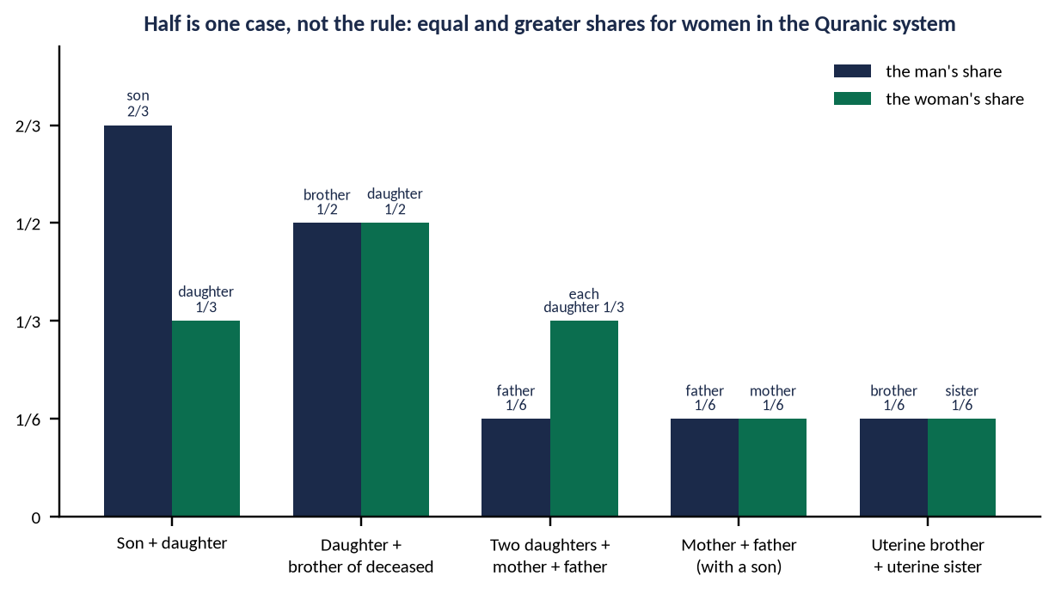
Figure 8 · Equal and greater shares for women in the Quranic system.

(4) Cases where the woman receives equal or more
- Father and mother of a deceased with a son: 1/6 each — equal.
- Uterine brother and sister: equal shares.
- Daughter and the deceased's brother: 1/2 each — equal.
- Two daughters, mother and father: each daughter 1/3, the father 1/6 — the woman receives twice the man.

(5) No one may cut her out
✦ HADITH
إِنَّ اللَّهَ قَدْ أَعْطَى كُلَّ ذِي حَقٍّ حَقَّهُ، فَلَا وَصِيَّةَ لِوَارِثٍ
“Allah has given every rightful person his right; there is no bequest for an heir.” (Abu Dawud and Al-Tirmidhi)
➜ The shares are fixed by Allah.

✦ QURAN
﴿… وَمَن يَعۡصِ ٱللَّهَ وَرَسُولَهُۥ وَيَتَعَدَّ حُدُودَهُۥ يُدۡخِلۡهُ نَارًا خَٰلِدٗا فِيهَا وَلَهُۥ عَذَابٞ مُّهِينٞ﴾
“And whoever disobeys Allah and His Messenger and transgresses His limits — He will put him into the Fire to abide therein, and he will have a humiliating punishment.” (An-Nisa, Quran)
➜ These are the limits of Allah; whoever disobeys Allah and His Messenger and transgresses His limits enters the Fire — the warning after the inheritance verses.

(6) The Hanafi order of distribution
From the estate: (1) funeral expenses → (2) debts (including unpaid mahr) → (3) bequest up to one-third, not for an heir → (4) the rest to the heirs: first the sharers (ashab al-furud), then the residuaries ('asabah).

7.5 The denial of women's inheritance in Pakistan
- Custom: daughters and sisters asked to give up their share ('haq bakhshwana') for the sake of brothers or to keep land in the family.
- Law: PPC 498A (2011) — depriving a woman of inheritance by deceit or coercion is a crime (5–10 years); the Enforcement of Women's Property Rights Act 2020 — an ombudsperson to restore property quickly; the Supreme Court has held that a 'relinquishment' by a woman must be free and informed.
TRAP · 'HALF THE SHARE' IS NOT 'HALF THE VALUE'
Never write that Islam values a woman at half a man. The 2:1 rule in one situation is balanced by the man's financial duties; in many situations women receive equal or more. Show the table and the figure.

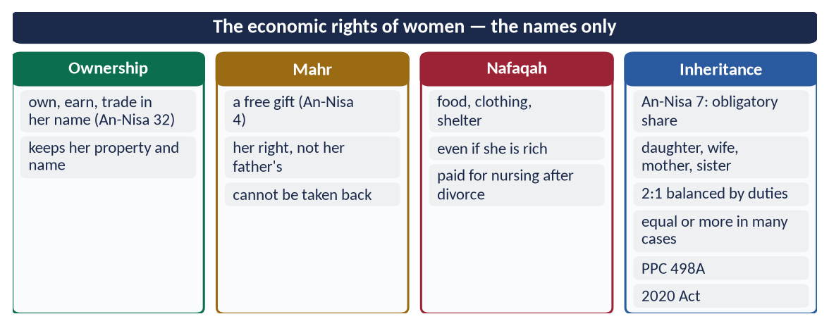
Figure 9 · At a glance — the economic rights of women — the names only. The detail is in the sections above.

Chapter 8 · Women's Rights and the Feminist Movement
Asked in 2019: 'the rights of women in Islam in the context of the current wave of the feminist movement'.

8.1 Feminism — meaning and waves
Feminism is the movement for the political, economic and social equality of women with men.
Wave | Period | Main demands
First wave | 1848–1920 | Right to vote and to own property (Seneca Falls, 1848; US vote 1920)
Second wave | 1960s–1980s | Equal pay, work, education, reproductive and family law (Simone de Beauvoir, The Second Sex, 1949; Betty Friedan, The Feminine Mystique, 1963)
Third wave | 1990s–2000s | Diversity of women's experience; identity; choice
Fourth wave | 2010s– | Online activism, harassment and violence (#MeToo, 2017); body autonomy

In Pakistan, women's rights work has a long history — Fatima Jinnah; Begum Ra'ana Liaquat Ali Khan (founded APWA, 1949); the laws of 2010–2020 against harassment and anti-women practices. Recent street marches and social-media campaigns have sharpened the debate.

8.2 Where Islam agrees with the demands of women's movements
Demand | Islamic teaching
Dignity and equality of worth | One soul (An-Nisa 1); 'women are the twin halves of men' (Abu Dawud)
Education | Obligatory on every Muslim (Ibn Majah); a day for women (Al-Bukhari)
Property and earning | An-Nisa 32: her earning is hers
Consent in marriage | Khansa's marriage annulled (Al-Bukhari)
Right to divorce | Khula' (Al-Baqarah 229)
Protection from violence | 'Those who beat their wives are not the best of you' (Abu Dawud)
Protection from harassment | Lowering the gaze (An-Nur 30); penalty for slander (An-Nur 4)
Public participation | Bay'ah of women; Umm Salamah's counsel; Al-Shifa in the market

8.3 Where Islam differs

(1) Equality is not identity
Islam gives equal dignity but different, complementary roles — the man as maintainer, the woman free of financial duty; both partners in the home.
✦ QURAN
﴿… لِّلرِّجَالِ نَصِيبٞ مِّمَّا ٱكۡتَسَبُواْۖ وَلِلنِّسَآءِ نَصِيبٞ مِّمَّا ٱكۡتَسَبۡنَۚ …﴾
“For men is a share of what they have earned, and for women is a share of what they have earned.” (An-Nisa, Quran)
➜ 'Do not wish for that by which Allah has given some of you more than others' — for men a share of what they earned, and for women a share of what they earned.

(2) Freedom within moral limits
Islam rejects sexual freedom outside marriage and the commercial use of the woman's body in advertising — which it sees as exploitation, not liberation.
✦ QURAN
﴿قُل لِّلۡمُؤۡمِنِينَ يَغُضُّواْ مِنۡ أَبۡصَٰرِهِمۡ وَيَحۡفَظُواْ فُرُوجَهُمۡۚ ذَٰلِكَ أَزۡكَىٰ لَهُمۡۚ إِنَّ ٱللَّهَ خَبِيرُۢ بِمَا يَصۡنَعُونَ﴾
“Tell the believing men to reduce [some] of their vision and guard their private parts. That is purer for them. Indeed, Allah is Acquainted with what they do.” (An-Nur, Quran)
➜ The believing men are told first to lower their gaze and guard their chastity — the moral duty begins with men.

(3) The family, not the individual, as the unit
Some strands of feminism treat marriage and motherhood as oppression; Islam treats them as worship and gives the mother three times the father's right.

(4) Revelation, not changing opinion, as the standard
Rights fixed by Allah — inheritance, mahr, maintenance — are not open to repeal by majority vote.

8.4 The balanced Islamic answer — 'equity, not identity'
- (a) Support every just demand: education, work with dignity, safety, inheritance, consent.
- (b) Separate Islam from culture: most oppression of women in Muslim lands — honour killing, denial of inheritance, forced marriage — is tribal custom, condemned by Islam.
- (c) Reject slogans that attack the family or modesty.
- (d) Present the Prophetic model: Khadijah the merchant, Aishah the scholar, Umm Salamah the counsellor, Nusaybah the defender.
✦ SCHOLARLY VIEW
Allama Muhammad Iqbal · Zarb-e-Kalim (poems on women)
Iqbal honoured the woman as the source of the nation's strength, but warned that a freedom that separates her from her role as the maker of character would harm both her and society.
➜ Honour with balance.

DEBATE · IS ISLAMIC FEMINISM POSSIBLE?
Some Muslim women scholars argue for rights from within the Quran and Sunnah — rereading texts that culture had distorted. This is valid when it follows sound principles of interpretation; it fails when it rejects clear texts (inheritance, qawwamah) to fit Western theory. The safe position for the paper: Islam already gave the rights; the task is to implement them.

Chapter 9 · The Rights of Non-Muslims, Children, the Elderly, Workers and the Disabled
Never asked directly — likely.

9.1 Rights of non-Muslims (minorities) in an Islamic state

(1) The Quranic principles
✦ QURAN
﴿لَآ إِكۡرَاهَ فِي ٱلدِّينِۖ قَد تَّبَيَّنَ ٱلرُّشۡدُ مِنَ ٱلۡغَيِّۚ …﴾
“There is no compulsion in religion; the right course has become clear from the wrong.” (Al-Baqarah, Quran)
➜ No compulsion in religion.

✦ QURAN
﴿لَّا يَنۡهَىٰكُمُ ٱللَّهُ عَنِ ٱلَّذِينَ لَمۡ يُقَٰتِلُوكُمۡ فِي ٱلدِّينِ وَلَمۡ يُخۡرِجُوكُم مِّن دِيَٰرِكُمۡ أَن تَبَرُّوهُمۡ وَتُقۡسِطُوٓاْ إِلَيۡهِمۡۚ إِنَّ ٱللَّهَ يُحِبُّ ٱلۡمُقۡسِطِينَ﴾
“Allah does not forbid you from those who do not fight you because of religion and do not expel you from your homes - from being righteous toward them and acting justly toward them. Indeed, Allah loves those who act justly.” (Al-Mumtahanah, Quran)
➜ Allah does not forbid you kindness and justice to those who do not fight you.

✦ QURAN
﴿… وَلَوۡلَا دَفۡعُ ٱللَّهِ ٱلنَّاسَ بَعۡضَهُم بِبَعۡضٖ لَّهُدِّمَتۡ صَوَٰمِعُ وَبِيَعٞ وَصَلَوَٰتٞ وَمَسَٰجِدُ يُذۡكَرُ فِيهَا ٱسۡمُ ٱللَّهِ كَثِيرٗاۗ …﴾
“Were it not that Allah checks some people by means of others, monasteries, churches, synagogues and mosques — in which Allah's name is much mentioned — would have been demolished.” (Al-Hajj, Quran)
➜ Monasteries, churches and synagogues are protected alongside mosques.

(2) The Prophetic guarantee
✦ HADITH
أَلَا مَنْ ظَلَمَ مُعَاهَدًا، أَوِ انْتَقَصَهُ، أَوْ كَلَّفَهُ فَوْقَ طَاقَتِهِ، أَوْ أَخَذَ مِنْهُ شَيْئًا بِغَيْرِ طِيبِ نَفْسٍ، فَأَنَا حَجِيجُهُ يَوْمَ الْقِيَامَةِ
“Beware: whoever wrongs a non-Muslim under covenant, belittles him, burdens him beyond his ability or takes anything from him without his consent — I will argue against him on the Day of Resurrection.” (Abu Dawud)
➜ The Prophet ﷺ is the advocate of the minority.

✦ HADITH
مَنْ قَتَلَ مُعَاهَدًا لَمْ يَرِحْ رَائِحَةَ الْجَنَّةِ
“Whoever kills a non-Muslim under covenant will not smell the fragrance of Paradise.” (Al-Bukhari)

(3) Their rights
Life, property and honour; freedom of worship and places of worship (Najran treaty); their own personal law; justice in court; social welfare; exemption from military service (the jizyah in its place).

(4) The practice
- Umar (RA) gave an old, blind Jew a stipend from the treasury: 'We took jizyah from him in his youth; we will not abandon him in his old age' (Abu Yusuf, Kitab al-Kharaj).
- Ali (RA), as Caliph, lost a case over his shield to a non-Muslim before Qadi Shurayh because he lacked proper witnesses — the man accepted Islam on seeing such justice.
- Umar (RA) declined to pray inside the Church of the Holy Sepulchre in Jerusalem, so that Muslims would not later claim it.

(5) Pakistan
Articles 20 (freedom of religion), 22 (safeguards in education), 36 (protection of minorities), Objectives Resolution ('adequate provision … for minorities to freely profess and practise their religions'); reserved seats in the assemblies; the Quaid's speech of 11 August 1947.

9.2 Rights of children
✦ QURAN
﴿… وَلَا تَقۡتُلُوٓاْ أَوۡلَٰدَكُم مِّنۡ إِمۡلَٰقٖ نَّحۡنُ نَرۡزُقُكُمۡ وَإِيَّاهُمۡۖ …﴾
“Do not kill your children out of poverty; We provide for you and for them.” (Al-An'am, Quran)
➜ Do not kill your children out of poverty.

✦ QURAN
﴿وَٱلۡوَٰلِدَٰتُ يُرۡضِعۡنَ أَوۡلَٰدَهُنَّ حَوۡلَيۡنِ كَامِلَيۡنِۖ لِمَنۡ أَرَادَ أَن يُتِمَّ ٱلرَّضَاعَةَۚ وَعَلَى ٱلۡمَوۡلُودِ لَهُۥ رِزۡقُهُنَّ وَكِسۡوَتُهُنَّ بِٱلۡمَعۡرُوفِۚ …﴾
“Mothers shall breastfeed their children two complete years …; and upon the father is their provision and their clothing according to what is acceptable.” (Al-Baqarah, Quran)
➜ Breastfeeding for two years and the father's duty to provide.

✦ QURAN
﴿يَـٰٓأَيُّهَا ٱلَّذِينَ ءَامَنُواْ قُوٓاْ أَنفُسَكُمۡ وَأَهۡلِيكُمۡ نَارٗا وَقُودُهَا ٱلنَّاسُ وَٱلۡحِجَارَةُ عَلَيۡهَا مَلَـٰٓئِكَةٌ غِلَاظٞ شِدَادٞ لَّا يَعۡصُونَ ٱللَّهَ مَآ أَمَرَهُمۡ وَيَفۡعَلُونَ مَا يُؤۡمَرُونَ﴾
“O you who have believed, protect yourselves and your families from a Fire whose fuel is people and stones, over which are [appointed] angels, harsh and severe; they do not disobey Allah in what He commands them but do what they are commanded.” (At-Tahrim, Quran)
➜ 'Protect yourselves and your families from a Fire' — moral upbringing is a duty.

✦ HADITH
كُلُّكُمْ رَاعٍ وَكُلُّكُمْ مَسْئُولٌ عَنْ رَعِيَّتِهِ
“Each of you is a shepherd, and each of you is responsible for his flock.” (Al-Bukhari and Muslim)
➜ Parents answer for their children.

Rights: life, lineage (legitimacy), a good name, nursing and maintenance, education, love and equal treatment, protection from harm and exploitation. The Prophet ﷺ lengthened a prostration while his grandson rode on his back, and kissed Hasan (RA), saying 'whoever does not show mercy will not be shown mercy' (Al-Bukhari).
Pakistan: Article 11(3) — no child under 14 in factories and hazardous work; 25-A — free and compulsory education (5–16); child labour remains widespread.

9.3 Rights of the elderly and parents
✦ QURAN
﴿وَقَضَىٰ رَبُّكَ أَلَّا تَعۡبُدُوٓاْ إِلَّآ إِيَّاهُ وَبِٱلۡوَٰلِدَيۡنِ إِحۡسَٰنًاۚ إِمَّا يَبۡلُغَنَّ عِندَكَ ٱلۡكِبَرَ أَحَدُهُمَآ أَوۡ كِلَاهُمَا فَلَا تَقُل لَّهُمَآ أُفّٖ وَلَا تَنۡهَرۡهُمَا وَقُل لَّهُمَا قَوۡلٗا كَرِيمٗا﴾
“Your Lord has decreed that you worship none but Him, and that you be good to parents. If one or both of them reach old age with you, do not say to them even 'uff', nor repel them, but speak to them a noble word.” (Al-Isra, Quran)
➜ Do not say even 'uff' to parents in old age; speak to them a noble word.

✦ HADITH
لَيْسَ مِنَّا مَنْ لَمْ يَرْحَمْ صَغِيرَنَا وَيُوَقِّرْ كَبِيرَنَا
“He is not one of us who does not show mercy to our young and respect to our elders.” (Al-Tirmidhi)

The Prophet ﷺ said: 'Let him be humbled, let him be humbled' — the one whose parents reach old age with him and he does not enter Paradise by serving them (Muslim).

9.4 Rights of workers
✦ HADITH
أَعْطُوا الْأَجِيرَ أَجْرَهُ قَبْلَ أَنْ يَجِفَّ عَرَقُهُ
“Give the worker his wage before his sweat dries.” (Ibn Majah)
➜ Prompt and fair wages.

✦ HADITH
إِخْوَانُكُمْ خَوَلُكُمْ ... فَلْيُطْعِمْهُ مِمَّا يَأْكُلُ، وَلْيُلْبِسْهُ مِمَّا يَلْبَسُ، وَلَا تُكَلِّفُوهُمْ مَا يَغْلِبُهُمْ
“Your servants are your brothers … feed them from what you eat, clothe them from what you wear, and do not burden them beyond their strength.” (Al-Bukhari)
➜ Dignity, decent living and reasonable hours.

9.5 Rights of persons with disabilities
✦ QURAN
﴿عَبَسَ وَتَوَلَّىٰٓ ۝ أَن جَآءَهُ ٱلۡأَعۡمَىٰ﴾
“The Prophet frowned and turned away. Because there came to him the blind man, [interrupting].” (Abasa, Quran)
➜ 'He frowned and turned away because the blind man came to him' — the Prophet ﷺ was corrected for not attending to Abdullah ibn Umm Maktum (RA).

Afterwards he honoured him and appointed him his deputy over Madinah more than once, and he gave the adhan. Islam exempts the disabled from what they cannot do (An-Nur 61) and gives them a claim on public welfare.
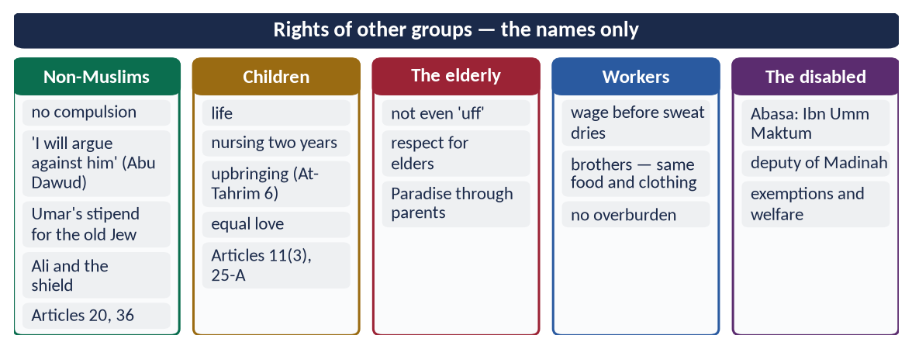
Figure 10 · At a glance — rights of other groups — the names only. The detail is in the sections above.

Chapter 10 · The Institution of the Family and Its Challenges
Asked as 'stability of modern society depends upon a strong family system' (2015) and 'the challenges for the institution of family and its role in the present era' (2026).

10.1 The family in Islam — purpose and foundation
✦ QURAN
﴿يَـٰٓأَيُّهَا ٱلنَّاسُ ٱتَّقُواْ رَبَّكُمُ ٱلَّذِي خَلَقَكُم مِّن نَّفۡسٖ وَٰحِدَةٖ وَخَلَقَ مِنۡهَا زَوۡجَهَا وَبَثَّ مِنۡهُمَا رِجَالٗا كَثِيرٗا وَنِسَآءٗۚ …﴾
“O mankind, fear your Lord, who created you from one soul, created from it its mate, and spread from both of them many men and women.” (An-Nisa, Quran)
➜ All people come from one soul and its mate — the family is the first human institution, older than any state.

✦ QURAN
﴿وَمِنۡ ءَايَٰتِهِۦٓ أَنۡ خَلَقَ لَكُم مِّنۡ أَنفُسِكُمۡ أَزۡوَٰجٗا لِّتَسۡكُنُوٓاْ إِلَيۡهَا وَجَعَلَ بَيۡنَكُم مَّوَدَّةٗ وَرَحۡمَةًۚ إِنَّ فِي ذَٰلِكَ لَأٓيَٰتٖ لِّقَوۡمٖ يَتَفَكَّرُونَ﴾
“And of His signs is that He created for you from yourselves mates that you may find tranquillity in them; and He placed between you affection and mercy. Indeed in that are signs for a people who give thought.” (Ar-Rum, Quran)
➜ He created mates for you that you may find tranquillity in them, and placed between you love and mercy (mawaddah wa rahmah).

✦ QURAN
﴿وَٱلَّذِينَ يَقُولُونَ رَبَّنَا هَبۡ لَنَا مِنۡ أَزۡوَٰجِنَا وَذُرِّيَّـٰتِنَا قُرَّةَ أَعۡيُنٖ وَٱجۡعَلۡنَا لِلۡمُتَّقِينَ إِمَامًا﴾
“And those who say, "Our Lord, grant us from among our wives and offspring comfort to our eyes and make us an example for the righteous.” (Al-Furqan, Quran)
➜ 'Our Lord, grant us from our spouses and children the comfort of our eyes.'

✦ HADITH
النِّكَاحُ مِنْ سُنَّتِي، فَمَنْ لَمْ يَعْمَلْ بِسُنَّتِي فَلَيْسَ مِنِّي
“Marriage is my Sunnah; whoever does not act on my Sunnah is not of me.” (Ibn Majah)
➜ Marriage is worship and Sunnah.

✦ SCHOLARLY VIEW
Shah Waliullah Dehlawi · Hujjat Allah al-Baligha
Shah Waliullah described the household (tadbir al-manzil) as the second stage of human civilisation after individual needs: from it come the neighbourhood, the city and the state; if the household is corrupt, all higher stages are corrupted.
➜ The family is the base of civilisation.

10.2 The structure of the Islamic family
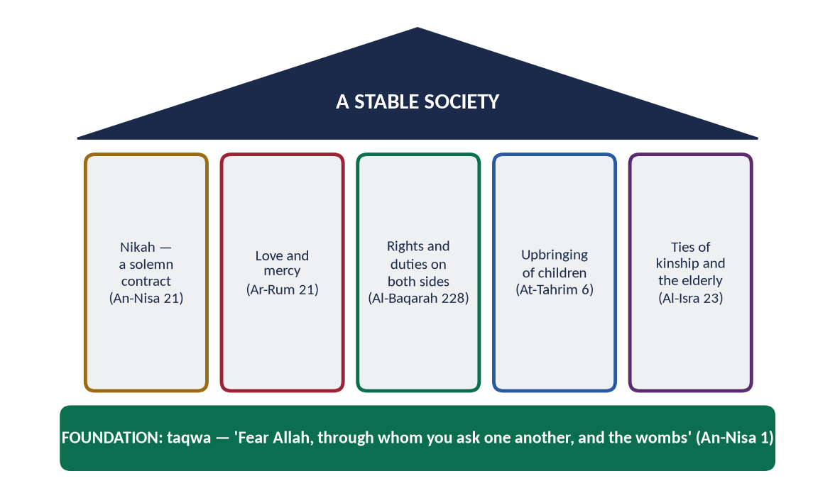
Figure 11 · The Islamic family: a foundation of taqwa, five pillars, and a stable society on top.
- (a) Nikah — a solemn contract: 'they have taken from you a firm covenant' (An-Nisa 21) — with consent, witnesses and mahr.
- (b) Love and mercy (Ar-Rum 21).
- (c) Rights and duties on both sides (Al-Baqarah 228).
- (d) Upbringing of children (At-Tahrim 6).
- (e) Extended ties: parents (Al-Isra 23), relatives (silat al-rahim), neighbours (An-Nisa 36).
✦ HADITH
مَنْ أَحَبَّ أَنْ يُبْسَطَ لَهُ فِي رِزْقِهِ، وَيُنْسَأَ لَهُ فِي أَثَرِهِ، فَلْيَصِلْ رَحِمَهُ
“Whoever wishes his provision to be increased and his life to be extended, let him keep ties with his relatives.” (Al-Bukhari and Muslim)
➜ Kinship ties bring blessing.

10.3 The functions of the family — why society's stability depends on it (2015)
Function | How it keeps society stable
Moral training | The first school — honesty, respect and faith learned at home
Emotional security | Love and mercy prevent loneliness, depression and addiction
Protection of lineage | Clear parentage; rights of inheritance and names
Control of desire | Marriage channels desire lawfully; reduces crime and disease
Economic security | Maintenance of wife, children, parents; inheritance
Care of the weak | Children, the elderly and the disabled cared for without the state
Social cohesion | Kinship ties connect families into communities
Transmission of culture | Language, religion and values passed on

10.4 Safeguards Islam built around the family
- Chastity and modesty (An-Nur 30–31); ban on zina and slander (An-Nur 2, 4).
- Arbitration before divorce:
✦ QURAN
﴿وَإِنۡ خِفۡتُمۡ شِقَاقَ بَيۡنِهِمَا فَٱبۡعَثُواْ حَكَمٗا مِّنۡ أَهۡلِهِۦ وَحَكَمٗا مِّنۡ أَهۡلِهَآ إِن يُرِيدَآ إِصۡلَٰحٗا يُوَفِّقِ ٱللَّهُ بَيۡنَهُمَآۗ إِنَّ ٱللَّهَ كَانَ عَلِيمًا خَبِيرٗا﴾
“And if you fear dissension between the two, send an arbitrator from his people and an arbitrator from her people. If they both desire reconciliation, Allah will cause it between them. Indeed, Allah is ever Knowing and Acquainted [with all things].” (An-Nisa, Quran)
➜ If you fear a breach, appoint an arbiter from his family and an arbiter from her family; if they want reconciliation, Allah will bring it about.

- Divorce as the last resort — in stages, with a waiting period (iddah) for reconsideration; the widely quoted report 'the most hated of lawful things to Allah is divorce' (Abu Dawud) expresses the spirit of An-Nisa 35.
- Privacy of the home (An-Nur 27).

10.5 The challenges to the family in the present era (2026)

(1) Social and cultural
- (a) From joint to nuclear family — urbanisation; the elderly left alone; old-age homes.
- (b) Rising divorce and khula' — family courts in Pakistan's big cities hear many thousands of cases a year.
- (c) Late marriage and dowry — expensive weddings and jahez delay marriage.
- (d) Weakening of kinship ties and neighbourhood.

(2) Technological
- (a) Social media and screens — less time together; comparison and jealousy; online harassment; exposure of children to indecent content.
- (b) The generation gap — parents and children living in different worlds.

(3) Economic
- (a) Inflation and unemployment — stress, quarrels, both parents working long hours.
- (b) Migration — fathers working abroad for years; children raised by one parent.

(4) Ideological
- (a) Individualism — marriage seen as a contract of convenience, not a covenant.
- (b) Redefinition of family in some societies and global media.
- (c) Materialism — success measured by money, not character.

(5) Violence and injustice within families
Domestic violence, forced marriage, denial of inheritance, neglect of elderly parents, drug addiction among the young.

10.6 The Islamic solutions
- (a) Return to taqwa — the foundation (An-Nisa 1): fear Allah 'through whom you ask one another, and the wombs'.
- (b) Easy, simple marriage — 'the most blessed marriage is the one with the least burden' (Ahmad); end dowry culture.
- (c) Rights and duties known and practised — pre-marriage counselling; the nikah nama explained.
- (d) Time for family — the Prophet ﷺ was 'in the service of his family' (Al-Bukhari).
- (e) Digital discipline — screen rules for children; the parent as a model (At-Tahrim 6).
- (f) Arbitration and reconciliation before divorce (An-Nisa 35); strengthen the Arbitration Councils of the MFLO 1961.
- (g) Care of the elderly at home (Al-Isra 23).
- (h) The state's duty — Article 35 (protect marriage, family, mother and child); family-friendly work hours; housing; family courts that reconcile.
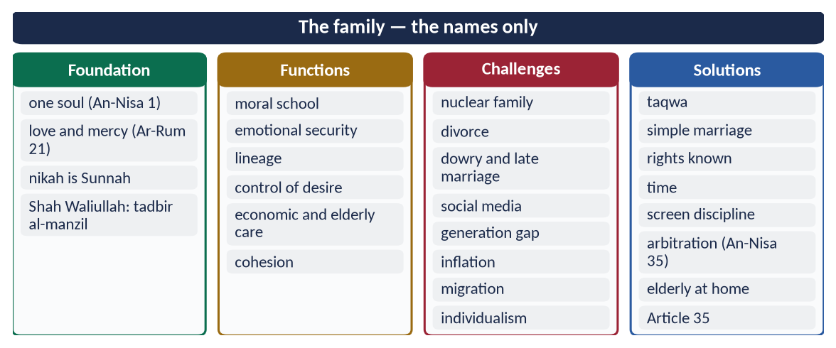
Figure 12 · At a glance — the family — the names only. The detail is in the sections above.

Part Two — Contemporary Challenges, Narratives and Hot Debates

11.1 The UDHR and the Cairo Declaration — two languages of rights
The West says Muslim states use 'Shari'ah' to avoid rights; Muslims say the West uses 'rights' selectively. The balanced answer: both documents agree on most rights; the OIC must implement its own declaration (1990, revised 2020), and the West must apply the UDHR without double standards — Gaza, Kashmir and the treatment of refugees are the tests.

11.2 Women's-rights campaigns in Pakistan — the balanced answer
Support the just demands (safety, inheritance, education, consent, work) with the Quran and Sunnah; reject slogans that attack the family or modesty; and remember that the strongest weapon against custom is Islamic knowledge — most anti-women practices are condemned by the Shari'ah itself.

11.3 Cultural practices against Islam
Practice | Why it is against Islam | Pakistani law
Denial of inheritance | An-Nisa 7: an obligatory share | PPC 498A (2011); 2020 Act
Forced marriage; vani, swara | Consent required (Al-Bukhari) | PPC 310A, 498B (2011)
Honour killing | Murder (Al-Ma'idah 32); only a court punishes | 2016 Honour Act
Dowry burden | Not required; mahr is the husband's duty | Dowry and Bridal Gifts (Restriction) Act 1976
Marriage to the Quran | A mockery of the Book | PPC 498C (2011)
Workplace harassment | An-Nur 30; honour protected | Protection against Harassment of Women at the Workplace Act 2010

11.4 Family breakdown
Divorce, social media, the generation gap, working parents and migration are straining the Pakistani family, which is still the country's main social safety net. The Islamic answer is prevention (taqwa, easy marriage, time, arbitration) more than cure.

11.5 The elderly, children and persons with disabilities
Old-age homes are growing in big cities; child labour and out-of-school children remain high; persons with disabilities face buildings, schools and jobs closed to them. The Quran's word for the young and old is mercy and respect; the state's duty is in Articles 11, 25-A, 35 and 38 and the ICT Rights of Persons with Disability Act 2020.
DEBATE · 'HUMAN RIGHTS ARE A WESTERN IMPOSITION'
No: the Farewell Sermon declared them in 632. But the modern system of monitoring and treaties is largely Western-built. The mature position: accept the common ground, contribute the Islamic foundation, and reject only what clearly contradicts revelation.

Part Three — The Examiner's Record and Five Likely Questions

12.1 Every question on this topic, 2015–2026
Year | Question | Ch.
2015 Q8 | Stability of modern society depends upon a strong family system in the light of Islamic principles. Discuss. | 10
2017 Q3 | Write a comprehensive note on the right of inheritance granted to women by Islam. | 7
2019 Q4 | Describe the rights of women in Islam in the context of current wave of the feminist movement. | 8
2020 Q4 | 'The last Sermon of the Holy Prophet (PBUH) is the basic document for awakening of conscience of mankind for human rights'. Discuss. | 2
2020 Q7 | 'Islam teaches the lesson of human respect and dignity irrespective of colour, race and creed'. Discuss. | 4
2021 Q3 | Islam provides better rights to men and women than all other religions. Explore with arguments. | 5
2022 Q2 | Explain the concept of Human Rights in Islamic thought in specification of 'Status of Women in Islam'. | 1, 5
2023 Q4 | Elaborate the rights of daughters granted by Islam and how these are denied by Muslims in the contemporary world? | 6
2023 Q8 | Notes: (i) Human rights in the light of the Sermon of the Farewell Pilgrimage; (ii) Social justice in an Islamic society. | 2, 4
2024 Q5 | How does Islam highlight human dignity and greatness? Discuss. | 4
2026 Q2 | Provide a comparative and critical analysis of the human rights granted by Islam with those enshrined in the UDHR. | 3
2026 Q8 | What are the challenges for the 'institution of family and its role' in the present era? Discuss them in the light of Islamic teachings. | 10

All twelve are answered in T4QA. The 2025 question on the classist lifestyle belongs to Topic 5 but draws on Chapter 4 (equality).

12.2 What the record teaches
- Asked in nine of twelve years; 2020, 2023 and 2026 had two questions each.
- Women is the favourite theme — never asked the same way twice.
- The latest papers move to critical and contemporary framing: the UDHR (2026), family challenges (2026), denial by Muslims (2023).
- Never asked: non-Muslims' rights; children; the elderly; workers; the economic rights of women as a whole.

12.3 Five likely questions
1. Discuss the rights of non-Muslims (minorities) in an Islamic state in the light of the Quran, Sunnah and the Charter of Madinah.
2. Islam guarantees the economic rights of women. Explain with reference to mahr, maintenance, inheritance and property.
3. What is the Islamic concept of human dignity? How does it differ from the Western concept?
4. Discuss the rights and duties of husband and wife, and the role of the family in the stability of society.
5. Islam protects the rights of children and the elderly. Discuss in the context of Pakistani society.

Part Four — The One-Liner Bank

One-liners · Human rights in Islam
1. Rights in Islam are of two kinds: Huquq Allah and Huquq al-'Ibad.
2. The rights of people are not forgiven by Allah until the wronged person forgives.
3. 'We have honoured the children of Adam' — Al-Isra 70.
4. Killing one soul is like killing all mankind — Al-Ma'idah 32.
5. The five Maqasid: din, nafs, 'aql, nasl, mal.
6. The Maqasid were set out by Imam al-Ghazali (Al-Mustasfa) and developed by Imam al-Shatibi (Al-Muwafaqat).
7. 'The best jihad is a word of justice before a tyrant ruler' — Abu Dawud and Al-Tirmidhi.
8. 'No bearer of burdens shall bear the burden of another' — Al-An'am 164.
9. Privacy of homes: An-Nur 27.
10. 'In their wealth is a right for the one who asks and the deprived' — Adh-Dhariyat 19.
11. 'If Fatimah daughter of Muhammad stole, I would cut her hand' — the case of the Makhzumi woman.
12. The intercessor in the Makhzumi case: Usamah ibn Zayd (RA).

One-liners · The Farewell Sermon
13. Delivered on 9 Dhul Hijjah 10 AH (March 632) at Arafat.
14. Audience: more than a hundred thousand Companions.
15. 'This day I have perfected your religion' — Al-Ma'idah 3, revealed at Arafat.
16. 'Your lives, property and honour are sacred' — Al-Bukhari.
17. 'No Arab over a non-Arab … except by taqwa' — Musnad Ahmad.
18. 'Fear Allah concerning women; you took them as a trust from Allah' — Muslim.
19. First riba abolished: that of Abbas ibn Abd al-Muttalib.
20. First blood-claim abolished: that of Ibn Rabi'ah ibn al-Harith.
21. 'No offender is responsible except for his own offence' — Al-Tirmidhi.
22. 'There is no bequest for an heir' — Abu Dawud and Al-Tirmidhi.
23. 'Let the present convey to the absent' — Al-Bukhari.
24. The Sermon came about 580 years before Magna Carta (1215).

One-liners · Islam and the UDHR
25. UDHR adopted on 10 December 1948 — Human Rights Day.
26. The UDHR has 30 articles.
27. The UDHR vote: 48–0–8; Pakistan voted in favour.
28. UN members in 1948: 58.
29. The two Covenants of 1966: ICCPR and ICESCR.
30. The Cairo Declaration on Human Rights in Islam: OIC, 1990, 25 articles.
31. Revised OIC Declaration on Human Rights: 2020.
32. Universal Islamic Declaration of Human Rights: 1981.
33. Fundamental Rights in Pakistan's Constitution: Articles 8–28.
34. Muslim states' main reservations to the UDHR: Articles 16 and 18.
35. Duties in the UDHR appear in Article 29.
36. 'Breaking a dead man's bone is like breaking it alive' — Abu Dawud.

One-liners · Dignity and equality
37. 'We created man in the best of stature' — At-Tin 4.
38. 'I will make upon the earth a khalifah' — Al-Baqarah 30.
39. The angels prostrated to Adam — Al-Baqarah 34.
40. Man accepted the trust (amanah) — Al-Ahzab 72.
41. The diversity of languages and colours is a sign of Allah — Ar-Rum 22.
42. 'People are the children of Adam, and Adam was from dust' — Abu Dawud and Al-Tirmidhi.
43. 'Allah does not look at your faces and wealth but at your hearts and deeds' — Muslim.
44. 'You are a man in whom there is Jahiliyyah' — to Abu Dharr (RA).
45. The black Companion who gave the adhan on the Ka'bah: Bilal (RA).
46. 'Salman is one of us, the people of the house' — Al-Hakim.
47. 'Since when have you enslaved people whose mothers bore them free?' — Hazrat Umar (RA).
48. Iqbal's philosophy of the self: khudi.
49. 'Women are the twin halves of men' — Abu Dawud and Al-Tirmidhi.
50. Messengers were sent so that people may uphold justice — Al-Hadid 25.
51. Social justice in Pakistan's Constitution: Article 37.

One-liners · Status of women
52. The girl buried alive will be asked for what sin she was killed — At-Takwir 8–9.
53. Grief at the birth of a daughter is condemned in An-Nahl 58–59.
54. In the Quran, both Adam and Hawwa repented — Al-A'raf 23.
55. Equal reward for men and women: Al-Ahzab 35; Aal-e-Imran 195; An-Nahl 97.
56. Sati was abolished in India in 1829.
57. English married women gained property rights through the Acts of 1870 and 1882.
58. Women's vote: UK 1918/1928, USA 1920, Switzerland 1971.
59. The Second Sex (1949): Simone de Beauvoir; The Feminine Mystique (1963): Betty Friedan.
60. First women's rights convention: Seneca Falls, 1848.
61. #MeToo — the fourth wave, 2017.
62. APWA was founded in 1949 by Begum Ra'ana Liaquat Ali Khan.

One-liners · Daughter, wife, mother, citizen
63. Whoever raises two daughters will be with the Prophet ﷺ like two joined fingers — Muslim.
64. Daughters well treated are a shield from the Fire — Al-Bukhari and Muslim.
65. 'Fear Allah and be just between your children' — Al-Bukhari and Muslim.
66. The woman whose forced marriage was annulled: Khansa bint Khidam (RA).
67. 'Fatimah is a part of me' — Al-Bukhari.
68. Daughters are mentioned first among Allah's gifts — Ash-Shura 49.
69. 'Live with them in kindness' — An-Nisa 19.
70. 'They are clothing for you and you are clothing for them' — Al-Baqarah 187.
71. Women have rights like their obligations — Al-Baqarah 228.
72. Qawwamun (An-Nisa 34) = protectors and maintainers — a duty of care.
73. 'The best of you are the best to their wives' — Al-Tirmidhi.
74. Khula' of the wife of Thabit ibn Qays — Al-Bukhari.
75. 'Your mother' — said three times, then 'your father' — Al-Bukhari and Muslim.
76. 'Paradise is beneath her feet' — Al-Nasa'i and Ibn Majah.
77. 'Weakness upon weakness' — the mother's burden, Luqman 14.
78. Market supervisor appointed by Umar (RA): Al-Shifa bint Abdullah.
79. Nurse of the Prophet's ﷺ battles: Rufaydah al-Aslamiyyah.
80. Hazrat Aishah (RA) narrated about 2,210 hadith.
81. Believing men and women are allies of one another — At-Tawbah 71.
82. Anti-Women Practices Act: 2011 (PPC 310A, 498A, 498B, 498C).
83. Honour-killing law: 2016.
84. Constitution: Article 25 (equality), 34 (women), 35 (family).

One-liners · Economic rights and inheritance
85. For women is a share — little or much, an obligatory share — An-Nisa 7.
86. 'For the male, the like of the share of two females' — An-Nisa 11.
87. One daughter alone: 1/2; two or more: 2/3.
88. Wife: 1/4 without children; 1/8 with children.
89. Mother: 1/6 with children; 1/3 without.
90. Uterine brothers and sisters share equally.
91. Two daughters with both parents: each daughter 1/3, father 1/6.
92. Bequest limit: one-third, not for an heir.
93. Order: funeral → debts → bequest → heirs.
94. Mahr is a free gift — An-Nisa 4.
95. Mahr cannot be taken back, 'even a heap of gold' — An-Nisa 20.
96. Mahr and nikah registration: Muslim Family Laws Ordinance, 1961.
97. Depriving women of inheritance: PPC 498A.
98. Enforcement of Women's Property Rights Act: 2020.

One-liners · Other rights and the family
99. 'Whoever wrongs a mu'ahad … I will argue against him' — Abu Dawud.
100. The Caliph who gave a stipend to an old Jew: Umar (RA) (Kitab al-Kharaj, Abu Yusuf).
101. The judge in the case of Ali's shield: Qadi Shurayh.
102. Minorities in Pakistan's Constitution: Article 36.
103. 'Give the worker his wage before his sweat dries' — Ibn Majah.
104. The blind Companion of Surah Abasa: Abdullah ibn Umm Maktum (RA).
105. No child under 14 in hazardous work — Article 11(3).
106. 'Each of you is a shepherd' — Al-Bukhari and Muslim.
107. Love and mercy between spouses — Ar-Rum 21.
108. Marriage is a firm covenant — An-Nisa 21.
109. Arbiters from both families — An-Nisa 35.
110. 'Protect yourselves and your families from a Fire' — At-Tahrim 6.
111. 'Marriage is my Sunnah' — Ibn Majah.
112. The household as a stage of civilisation (tadbir al-manzil) — Shah Waliullah.
113. Family Courts Act (Pakistan): 1964.
ONE-LINER COUNT
This topic carries 113 one-liners, numbered 1–113. Revise them in blocks of twenty; tick the ones you can answer without looking.

Part Five — Revision Notes · Topic 4
Read these on the night before the paper. Each chapter is compressed into chains (→) and short lists.

R4.0 The topic in ten lines
1. Rights → from Allah → cannot be withdrawn → joined with duties → accountable in the Hereafter.
2. Maqasid → din · nafs · 'aql · nasl · mal → the map of all rights.
3. Farewell Sermon → life · property · honour · equality · women · riba · feuds · personal guilt · inheritance · convey.
4. UDHR → 1948, 30 articles, 48–0–8 → agree on most → differ on source, duties, scope, enforcement → critique both.
5. Dignity → honoured, best stature, spirit, khalifah, knowledge, angels, universe, trust.
6. Equality → one soul → Adam from dust → hearts not faces → Bilal, Abu Dharr, Salman, Usamah → Umar: 'born free'.
7. Women → before Islam (burial, no inheritance, coverture, sati) → Islam: one soul, equal reward, no blame for the Fall.
8. Life-cycle → daughter (life, love, education, consent, inheritance) → wife (mahr, nafaqah, kindness) → mother (three times) → citizen.
9. Inheritance → An-Nisa 7, 11, 12 → 2:1 balanced by duties → equal or more in many cases → 498A.
10. Family → Ar-Rum 21 → functions → challenges → taqwa, easy marriage, arbitration, Article 35.

R4.1 Chapter 1 · Human rights in Islam
- (i) Concept: rights of a human being → Islam: given by Allah → permanent → joined with duties → worship (Al-Isra 70).
- (ii) Two kinds: Huquq Allah → Huquq al-'Ibad → 'the bankrupt' (Muslim).
- (iii) Sources: Quran → Sunnah (Charter, Sermon) → Caliphs → ijma', ijtihad.
- (iv) Maqasid: Ghazali (Mustasfa) → Shatibi (Muwafaqat) → faith, life, intellect, lineage, property.
- (v) Rights: life (Al-Ma'idah 32) → dignity, honour → equality (Al-Hujurat 13) → justice (An-Nisa 58) → religion (Al-Baqarah 256) → property (An-Nisa 29) → privacy (An-Nur 27; Al-Hujurat 12) → opinion ('word of justice before a tyrant') → basic needs (Adh-Dhariyat 19) → personal responsibility (Al-An'am 164) → fair trial ('if Fatimah stole').
- (vi) Features: divine · universal · permanent · balanced · faith + law · comprehensive · moral.

R4.2 Chapter 2 · The Farewell Sermon
- (i) Occasion: 9 Dhul Hijjah 10 AH → Arafat → 100,000+ → Al-Ma'idah 3 revealed.
- (ii) Declarations: lives, property, honour sacred (Al-Bukhari) → no Arab over non-Arab (Ahmad) → women a trust (Muslim) → riba of Abbas abolished → blood of Ibn Rabi'ah abolished → no one pays for another → no bequest for an heir → servants fed as you eat → hold to the Book → convey to the absent.
- (iii) Why 'basic document': universal 'O people' → 580 years before Magna Carta → enforced first on his own family → conscience ('fear Allah') → complete.
- (iv) Table: Sermon ↔ UDHR Articles 1, 2, 3, 11, 12, 16, 17, 22–25.
- (v) Iqbal: spiritual democracy.

R4.3 Chapter 3 · Islam and the UDHR
- (i) Facts: 10 Dec 1948 → 30 articles → 48–0–8 → Pakistan yes → non-binding → Covenants 1966.
- (ii) Muslim documents: Sermon 632 → UIDHR 1981 → Cairo 1990 → OIC 2020 → Pakistan Arts 8–28.
- (iii) Agree: dignity, equality, life, no torture, fair trial, privacy, asylum, property, work, education.
- (iv) Differ: source (Allah vs human) → duties (Art. 29 only) → enforcement (veto vs taqwa + state + Hereafter) → scope (unborn, dead, animals, environment) → family vs individual → limits → Arts 16, 18 reservations.
- (v) Critique of UDHR: 58 states, colonies silent → double standards (Gaza, Kashmir) → veto → individualism → rights without duties.
- (vi) Self-critique: gap in practice → authoritarianism → weak OIC implementation.
- (vii) Verdict: great achievement; Islam firmer, fuller, balanced — proved only by practice.

R4.4 Chapter 4 · Dignity, equality, social justice
- (i) Dignity: Al-Isra 70 → At-Tin 4 → Al-Hijr 29 (spirit) → Al-Baqarah 30 (khalifah), 31 (names), 34 (angels) → Al-Jathiyah 13 (universe) → Al-Ahzab 72 (trust) → Iqbal's khudi.
- (ii) Colour and race: one soul (An-Nisa 1) → Adam from dust → Al-Hujurat 13 → colours a sign (Ar-Rum 22) → hearts not faces (Muslim).
- (iii) Practice: Bilal on the Ka'bah → Abu Dharr: 'Jahiliyyah in you' → Salman 'of us' → Usamah commands → Zayd marries Zaynab.
- (iv) Creed: no compulsion → Al-Mumtahanah 8 → 'is it not a soul?'.
- (v) Law: Umar and the Egyptian: 'born free' → Makhzumi woman.
- (vi) Men and women: Aal-e-Imran 195 → Al-Ahzab 35 → 'twin halves'.
- (vii) Every condition: poor, criminal, enemy, dead, servant.
- (viii) Social justice: Al-Hadid 25 → An-Nahl 90 → equality before law → circulation of wealth (Al-Hashr 7) → right of the needy → wages → accountable rulers → welfare (Umar, Umar ibn Abd al-Aziz) → Arts 3, 37, 38.

R4.5 Chapter 5 · Status of women: before and in Islam
- (i) Before: Arabia (burial, no inheritance, widows inherited) → Greece (Aristotle) → Rome (patria potestas) → India (sati till 1829) → England (coverture till 1870/1882).
- (ii) Islam: one soul → both repented (Al-A'raf 23) → equal reward (An-Nahl 97; Al-Ahzab 35).
- (iii) Comparison table: life, consent, property, inheritance, name, divorce, remarriage, education, vote (UK 1918/28, US 1920, Swiss 1971) → Annie Besant.
- (iv) Trap: compare practices, respect religions (Al-An'am 108).
- (v) 2021: add men's rights too.

R4.6 Chapter 6 · Daughter, wife, mother, citizen
- (i) Daughter: life (Al-An'am 151) → gift, named first (Ash-Shura 49) → two daughters = joined fingers (Muslim) → shield from Fire → be just between children → education → consent (Khansa) → inheritance (An-Nisa 7) → Fatimah 'part of me'.
- (ii) Denied today: neglect → education gap → forced marriage, vani, swara → inheritance 'gifted' away → dowry → honour killing → marriage to the Quran → laws 2011, 2016, 2020; Arts 25, 34, 35.
- (iii) Wife: mahr (An-Nisa 4) → maintenance (At-Talaq 6; Al-Baqarah 233) → kindness (An-Nisa 19) → 'best to their wives' → mutual rights (Al-Baqarah 228), clothing (187) → qawwamun = duty → khula' (Thabit's wife) → own name and property.
- (iv) Mother: Al-Isra 23 → Luqman 14 → 'your mother' ×3 → Paradise under her feet.
- (v) Citizen: Aishah's hadith → Khadijah's trade → Al-Shifa in the market → bay'ah → Umm Salamah → Rufaydah, Nusaybah → At-Tawbah 71 → Quaid 1944 → Iqbal.

R4.7 Chapter 7 · Economic rights
- (i) Principle: her earning is hers (An-Nisa 32).
- (ii) Mahr: free gift → hers → not taken back (An-Nisa 20) → prompt/deferred → nikah nama (MFLO 1961).
- (iii) Nafaqah: food, clothing, shelter → even if rich → iddah, pregnancy → paid nursing.
- (iv) Inheritance: An-Nisa 7 → widows not inherited (An-Nisa 19) → shares: daughter 1/2, 2/3 → wife 1/4, 1/8 → mother 1/6, 1/3 → sister → uterine equal → grandmother 1/6.
- (v) Why 2:1: his duties (mahr, maintenance) → her share untouched → several sources → only one case.
- (vi) Equal or more: parents 1/6 each → uterine siblings → daughter and brother 1/2 each → two daughters 1/3 each vs father 1/6.
- (vii) Fixed: no bequest for an heir → limits of Allah (An-Nisa 13–14) → order: funeral → debts → one-third bequest → heirs.
- (viii) Pakistan: 'haq bakhshwana' → PPC 498A → 2020 Act.

R4.8 Chapter 8 · Feminism
- (i) Waves: 1848–1920 vote → 1960s–80s equality (Beauvoir, Friedan) → 1990s identity → 2010s online, #MeToo.
- (ii) Pakistan: Fatima Jinnah → Ra'ana Liaquat, APWA 1949 → laws 2010–2020.
- (iii) Agree: dignity, education, property, consent, divorce, safety, harassment, participation.
- (iv) Differ: equality ≠ identity (An-Nisa 32) → freedom within morals (An-Nur 30) → family as unit → revelation as standard.
- (v) Answer: support just demands → separate Islam from culture → reject anti-family slogans → Prophetic women models → implement.

R4.9 Chapter 9 · Others' rights
- (i) Non-Muslims: no compulsion → Al-Mumtahanah 8 → places of worship (Al-Hajj 40) → 'I will argue against him' → Umar's stipend → Ali's shield → Umar at the Holy Sepulchre → Arts 20, 22, 36; 11 August 1947.
- (ii) Children: life → nursing → upbringing (At-Tahrim 6) → 'each a shepherd' → mercy (kissing Hasan) → Arts 11(3), 25-A.
- (iii) Elderly: not 'uff' → respect elders → 'let him be humbled'.
- (iv) Workers: wage before sweat dries → brothers, same food, no overburden.
- (v) Disabled: Abasa → Ibn Umm Maktum deputy of Madinah → exemptions.

R4.10 Chapter 10 · The family
- (i) Foundation: one soul (An-Nisa 1) → love and mercy (Ar-Rum 21) → comfort of eyes (Al-Furqan 74) → 'marriage is my Sunnah' → Shah Waliullah: tadbir al-manzil.
- (ii) Structure: nikah covenant (An-Nisa 21) → love → rights both sides → upbringing → kinship ('whoever wants provision increased…').
- (iii) Functions (2015): moral school → emotional security → lineage → control of desire → economics → care of weak → cohesion → culture.
- (iv) Safeguards: chastity → arbitration (An-Nisa 35) → divorce last resort → privacy.
- (v) Challenges (2026): nuclear family → divorce → dowry/late marriage → social media → generation gap → inflation → migration → individualism → violence.
- (vi) Solutions: taqwa → simple marriage ('least burden') → rights known → time → screen discipline → arbitration councils → elderly at home → Article 35.

R4.11 Part Two · Today
UDHR vs Cairo → implement both, no double standards · women's campaigns → support the just, reject the anti-family · cultural practices table (498A, 498B, 498C, 310A, 2016, 1976, 2010) · family breakdown → prevention · elderly, children, disabled → Articles 11, 25-A, 35, 38 · 'rights are Western' → no: 632.

R4.12 The figures to draw
The rights timeline (632 → 1215 → 1689 → 1776 → 1789 → 1948 → 1990 → 2020); the Sermon wheel; the woman's life-cycle (daughter → wife → mother → citizen); the inheritance bars (2:1, equal, double); the family house (taqwa foundation, five pillars).

